Substance Abuse and Mental Health Services Administration (SAMHSA)
Center for Mental Health Services (CMHS)
National Outcome Measures (NOMs)
Client-Level Measures for Discretionary Programs Providing Direct Services
QUESTION-BY-QUESTION
INSTRUCTION GUIDE
CMHS
Center for Mental Health Services
SAMHSA
June 2023

Table of Contents

Guide Overview 4
Deadlines and Reporting Requirements 5
Data Collection Points 6
Data Reporting Deadlines 11
Interviewing Guidelines 12
Consent 12
Translation 12
Reading the Questions 12
Child Clients 13
Caregiver Prompts 14
Reading the Response Options 14
Recording Responses 14
Question-by-Question Guide 16
Record Management 16
Behavioral Health Diagnoses 24
Demographic Data 32
A. Functioning 46
B. Stability in Housing 52
C. Education and Employment 56
D. Crime and Criminal Justice Status 63
E. Perception of Care 65
F. Social Connectedness 69
G. Program-Specific Questions 71
G1. ASSISTED OUTPATIENT TREATMENT Program-Specific Data Requirements 72
G2. LAW ENFORCEMENT AND BEHAVIORAL HEALTH PARTNERSHIPS FOR EARLY DIVERSION Program-Specific Data Requirements 75
G3. PROMOTING THE INTEGRATION OF PRIMARY AND BEHAVIORAL HEALTH Program-Specific Data Requirements 80
G4. MINORITY AIDS – SERVICES INTEGRATION Program-Specific Data Requirements 86
G5. HEALTHY TRANSITIONS Program-Specific Data Requirements 95
G6. ASSERTIVE COMMUNITY TREATMENT Program-Specific Data Requirements 98
G7. CLINICAL HIGH RISK FOR PSYCHOSIS Program-Specific Data Requirements 101
G8. CERTIFIED COMMUNITY BEHAVIORAL HEALTH CLINICS Program-Specific Data
Requirements 103
G9. NATIONAL CHILD TRAUMATIC STRESS INITIATIVE – CATEGORY 3 Program-Specific Data Requirements 108
H. Services Received and Clinical Discharge Status 111
Setting and Entering Annual Goals in SPARS 119
Setting Annual and Cumulative Goals for Clients Served 119
SPARS Data Entry for Clients Served Annual Goals 120
SPARS Data Entry Step-by-Step for Clients Served Annual Goals 122
Reporting NOMs in SPARS [Coming Soon!] 140
Accessing NOMs data from SPARS [Coming Soon!] 141

Guide Overview
These instructions are for collecting and reporting on the Center for Mental Health Services (CMHS) National Outcome Measures (NOMs) Client-Level Measures for Discretionary Programs Providing Direct Services, also known as Services Activities. A summary of each section of this document is as follows:
- Deadlines and reporting requirements—This section provides an explanation of the NOMs requirement, when interviews should be completed, and when data collected through the NOMs tool should be reported in SPARS. [Section updated: November 2022]
- Interviewing guidelines—This section explains how to use the interview tool, including how to use caregiver prompts and read questions. [Section updated: November 2022]
- Question by Question guide—This section is organized according to the sections of the Services tool. [Section updated: November 2022]
The following information is provided about each question:
Answered by—Indicates whether the question should be answered by grantee staff or the client/caregiver.
Intent/Key Points—Describes the intent of the question.
Skip Pattern—Indicates which items should be skipped and under what circumstances. There are certain questions that are irrelevant based on how a client answered a previous question.
Response Options—Lists all response options for the initial base question and provides any definitions if necessary.
Follow-on Questions—Lists all questions that follow the initial base question, their response options, and any definitions if necessary.
Additional Probes—Applicable for questions to be answered by client or caregiver; offers suggestions for probes that may help prompt the client’s memory or understanding.
Considerations for Grantee Staff—Applicable for questions to be answered by grantee staff; offers additional information for grantee staff to take into account that may help them provide answers.
Coding Topics—Clarifies how to count or record certain responses. Please pay close attention to coding topics because they address questions that could otherwise produce vague answers.
Cross-Check Items—Alerts the interviewer or person capturing the data to items that should be related and answers that should be verified if a contradiction occurs during the interview.
Tool Version Note—Based on 2022 revisions, provides information about changes to a specific question from previous versions of the data collection tool where appropriate.
- Setting and entering annual goals in SPARS—This section provides information on how to set annual and cumulative goals for clients served and how to enter these goals into SPARS. [Section updated: November 2022]
- Reporting NOMs in SPARS—This section includes information on how to directly enter data or how to batch upload data that was entered into a grantee-specific system. [Section updated: Coming soon!]
- Accessing NOMs data from SPARS—This section includes information on how to access and use SPARS reports and how to download NOMs data for further analysis. [Section updated: Coming soon!]

Deadlines and Reporting Requirements
CMHS grantees that provide direct services to clients are required to collect data from each client who receives grant-funded services. Grantees collect these data from individual clients using the NOMs Client-Level Measures tool, also known as the Services tool. Data are collected throughout a client’s episode of care and entered into the Substance Abuse and Mental Health Services Administration’s (SAMHSA’s) Performance Accountability and Reporting System (SPARS).
A client (or consumer) is defined as a person who is actively in treatment with a CMHS-funded program.
An episode of care begins when the client enters treatment or services, as defined by the program, and ends when the client is discharged and no longer receiving treatment or services with that grantee. A new episode of care begins when a client returns for treatment after a lapse of service of 90 calendar days or more after being discharged.

NOMs Requirement | CMHS grantees that provide direct services to clients are required to collect data from (or about) each client who receives grant-funded services.  For each episode of care, an attempt must be made to interview the client at three data collection points: baseline (initiation of grant-supported services), at reassessment, and at clinical discharge.  In instances where a grantee is unable to reach the client (or caregiver or proxy) for the interview, the client declined or refused consent, or the client was unable to provide consent the grantee is still required to use the NOMs tool to capture administrative data that can be completed by the grantee staff.

Data Collection Points
The data collection points for each section of the NOMs tool are presented in Table 1. For each section, it is noted whether the section must be completed only if an interview is conducted or if an administrative entry is required even when an interview was not conducted. Table 2 lists which programs have to also complete their assigned Section G subsection, and Table 3 summarizes the data collection points for only specific programs required to use Section G.
Table 1. Data Collection Points for NOMs Requirement
NOMs Section | Baseline | Reassessment | Discharge
Record Management | - Interview  - Administrative entry | - Interview  - Administrative entry | - Interview  - Administrative entry
Behavioral Health Diagnosis | - Interview  - Administrative entry | - Interview  - Administrative entry | - Interview  - Administrative entry
Demographic Data | - Interview
A. Functioning | - Interview | - Interview | - Interview
B. Stability in Housing | - Interview | - Interview | - Interview
C. Education and Employment | - Interview | - Interview | - Interview
D. Crime and Criminal Justice Status | - Interview | - Interview | - Interview
E. Perception of Care |  | - Interview | - Interview
F. Social Connectedness | - Interview | - Interview | - Interview
G. Program-Specific | See Table 3 | See Table 3 | See Table 3
H. Services Received and Clinical Discharge |  | - Interview  - Administrative entry | - Interview  - Administrative entry

Section G contains program-specific questions and is separated into subsections, with one subsection for each assigned program. Grantees should only complete the subsection specific for their program. Grantees implementing programs not listed in Table 2 should not complete Section G at any data collection point (baseline, reassessment, or discharge).
Table 2. Programs Required to Complete Section G Subsection
Acronym | Grant Program Name | Section G Subsection
AOT | Assisted Outpatient Treatment | G1
Early Div | Law Enforcement and Behavioral Health Partnerships for Early Diversion | G2
PIPBHC | Promoting Integration of Primary and Behavioral Health Care | G3
MAI-SI | Minority AIDS Initiative - Service Integration | G4
HTI | Healthy Transitions Initiative | G5
ACT | Assertive Community Treatment | G6
CHR-P | Clinical High Risk for Psychosis Program | G7
CCBHC | Certified Community Behavioral Health Clinics – Expansion Grants | G8
NCTSI | National Child Traumatic Stress Initiative Cat III | G9
Version Note: The Child Mental Health Initiative (CMHI), the Systems of Care Expansion Implementation (SOCXI) or Expansion and Sustainability (SOCXS), and Zero Suicide (ZeroSui) Programs no longer have assigned program-specific questions in the version of the NOMs tool approved in 2022.

In addition to the data collected from clients during interviews and administrative entries by grantee staff, two programs – Promoting the Integration of Primary and Behavioral Health Care (PIBHC or PIPBHC) and Certified Community Behavioral Health Centers (CCBHC)—have a requirement to collect physical health measurements and PIPBHC also has a requirement for a blood draw. The physical health measures and blood draw do not have to be completed at the same time as the interview and therefore are required even when an interview is not conducted, similar to the administrative entry reported by grantee staff.
The time points for Section G data collection are noted below in Table 3; more information on the requirements for physical health measurements and blood draw can be found in the Question by Question Guide subsections for G3. PIPBHC and G8. CCBHC, respectively. Note: “Q” in Table 3 is an abbreviation for “Question” (i.e., “Q1” refers to Question 1 in the coordinating Section G group of questions).
Table 3. Data Collection Points Section G
NOMs Section G | Baseline | Reassessment | Discharge
G1. AOT | - Interview (Q1) | - Interview (Q1, Q2)  - Administrative entry (Q2) | - Interview (Q1, Q2)  - Administrative entry (Q2)
G2. Early Div | - Interview (Q1, Q2)  - Administrative entry (Q1, Q2) | - Interview (Q1-Q3)  - Administrative entry (Q1, Q2) | - Interview (Q1-Q3)  - Administrative entry (Q1, Q2)
G3. PIPBHC | - Interview (Q1)  - Physical Health Measurements (Q2)  - Blood Draw (Q3) | - Interview (Q1)  - Physical Health Measurements (Q2)  - Blood Draw (Q3) | - Interview (Q1)  - Physical Health Measurements (Q2)  - Blood Draw (Q3)
G4. MAI-SI | - Interview (Q1-Q5) | - Interview (Q1-Q5) | - Interview (Q1-Q5)
G5. HTI | - Interview (Q1, Q2)  - Administrative entry (Q1, Q2) | - Interview (Q1, Q2)  - Administrative entry (Q1, Q2) | - Interview (Q1, Q2)  - Administrative entry (Q1, Q2)
G6. ACT |  | - Interview (Q1, Q2) | - Interview (Q1, Q2)
G7. CHR-P |  | - Interview (Q1)  - Administrative entry (Q1) | - Interview (Q1)  - Administrative entry (Q1)
G8. CCBHC | - Interview (Q1)  - Administrative entry (Q1)  - Physical Health Measurements (Q2) | - Interview (Q1)  - Administrative entry (Q1)  - Physical Health Measurements (Q2) | - Interview (Q1)  - Administrative entry (Q1)  - Physical Health Measurements (Q2)
G9. NCTSI |  | - Interview (Q1, Q2) | - Interview (Q1, Q2)

Baseline
Due date: For clients who initiate an episode of care after your grant begins using SPARS, baseline interviews must be completed within 7 calendar days after the episode of care is initiated. It may not be feasible to conduct a baseline interview for clients who are seeking treatment after experiencing a crisis or trauma. If it is not possible to conduct the baseline interview right away, you should conduct the interview as soon as possible but no later than 30 calendar days after an episode of care is initiated.
For clients who were already receiving care when your grant began using SPARS, baseline interviews must be completed the next time your project has contact with the client.
The completed interview must be entered into SPARS within 30 calendar days of the interview date.
Administrative entry: If a client is unable or unwilling to provide consent for the baseline interview, you are required to enter administrative information into SPARS within 30 days after the episode of care is initiated.

Reassessment
Due date: Reassessment interviews should be completed 3 or 6 months (calculated as 90 or 180 calendar days) after the baseline interview date for the client’s episode of care. Most CMHS grants will have reassessments at 6 months; your grant will be notified if your grant program will complete 3-month reassessments. The requirement for reassessment is set for the program cohort and will be communicated to grantees in program-specific guidance. Grantees do not have the option to choose one or the other reassessment schedules. Most programs will continue with a 6-month reassessment.
The completed interview must be entered into SPARS within 30 calendar days of the interview date.
When a new episode of care is initiated because a client re-enters treatment after a discharge, the timing of the reassessment will be based on the baseline interview date for the new episode of care.
Administrative entry: If a client is unable or unwilling to provide consent for the reassessment interview or a client cannot be reached for the reassessment interview but is still in care or treatment, the administrative entry should be made in SPARS within 30 days of the reassessment due date.

Reassessment Interview Rate
The goal is to conduct reassessment interviews with 100% of clients for whom a baseline record is submitted. You are not responsible for finding clients to conduct the reassessment interview unless it is a program or grant requirement. If a client cannot be found for the reassessment, an administrative reassessment entry is required.
The reassessment interview rate is calculated as the number of reassessments “received,” divided by the number of reassessments “due,” and then multiplied by 100 to calculate a percentage ((Received/Due) × 100).

Window or Time Frame Allowed for Completing the Reassessment
You do not have to complete the 3- or 6-month reassessment (calculated as 90 or 180 days) on the client’s exact due date. For interviews to count toward your reassessment interview rate, you must complete the reassessment interviews within a window that starts 30 calendar days before and ends 30 calendar days after the interview due date. Administrative entries for reassessment do not count towards the reassessment interview rate.
You are not required to conduct interviews outside the reassessment window. However, interviews that are conducted and submitted outside the window will be accepted by SPARS, and the data will be available in your data download and for use by CMHS. Interviews that are submitted outside of a window (before or after) will not be counted toward your reassessment interview rate. Note that this means an assessment at 90 days will not count towards the reassessment interview rate for a program required to do a 6-month reassessment.
The specific dates for a reassessment interview will be determined by the interview date of a client’s baseline interview. For example:
- 3-month Reassessment Interview Due (90 calendar days after baseline): A client enters the grant on January 3 and completes the baseline interview. The client will be due for a 3-month reassessment interview on April 3, and their reassessment window will span from March 3-May 3.
- 6-month Reassessment Interview Due (180 calendar days after baseline): A client enters the grant on January 3 and completes the baseline interview. The client will be due for a 6-month reassessment interview on July 2, and their reassessment window will span from June 2-August 2.

Clinical Discharge
A clinical discharge is defined by the grant to represent that the planned services were delivered, treatment goals were achieved, the client no longer was in need of care, or other definitions of no longer continuing services. Additionally, if the client has not had contact with the project for 90 calendar days or more or the client has died, the client should be discharged. Contact refers to services or referrals provided, phone calls related to a treatment plan (not scheduling), video calls, crisis intervention or emergency services.
Clinical discharges are not preset in the guidance in the same way as reassessments, they could occur at any point after baseline. Unless specified for the grant, clients do not have to be discharged in SPARS at the end of the grant (i.e., only for the reason of the grant funding ending) or when there is a change to the NOMs tool.
Due date: Clinical discharge interviews should be completed at the time of discharge. The goal is to interview all clients at discharge. If it is not possible to conduct the interview right away, you should conduct the interview as soon as possible but no longer than 30 calendar days after a client is discharged. You are not responsible for finding clients to conduct the discharge interview. The completed interview must be entered into SPARS within 30 calendar days of the interview date.
If a reassessment interview was conducted within 30 calendar days of a discharge, a separate clinical discharge interview is not required. However, an administrative clinical discharge must be completed.
See Coding Topics for Section H for definitions on the different types of discharges.
Administrative entry: If a clinical discharge interview is not conducted, you are required to report administrative information into SPARS within 30 calendar days of discharge or of being notified of the client’s death. If an administrative clinical discharge is submitted in place of an interview and then a clinical discharge interview is conducted, you will need to delete the administrative record prior to entering the interview record.

Data Reporting Deadlines
The goal is to enter or upload NOMs Client-Level Measures data into SPARS within 30 days of the interview date or due date of the interview for administrative entries, physical health measures, and blood draws.
Table 4. Due Dates and Windows
Data collection point | Due date | Window for data collection
Baseline | On day initiated (grant funded) services/treatment; or  On first day of receiving services/treatment after grant awarded | Interviews should be within 7 days of due date but no later than 30 days after due date.  Data collected by the grantee staff, such as Behavioral Health Diagnosis or Physical Health Measures, does not have to be from the same day as the interview but should be from within 30 days (before or after) of the due date.
Reassessment | 3 months: 90 days after baseline interview date | Interviews should be within 30 days (before or after) of due date.  Data collected by the grantee staff, such as Behavioral Health Diagnosis or Physical Health Measures, does not have to be from the same day as the interview but should be from within 30 days (before or after) of the due date.
 | 6 months: 180 days after baseline interview date
Discharge | On day of discharge; or  On day notified client deceased; or  90 days after last program contact with client | Interviews should be on the due date but no later than 30 days after due date.  Data collected by the grantee staff, such as Behavioral Health Diagnosis or Physical Health Measures, does not have to be from the same day as the interview but should be no earlier than 30 days before the due date.

Interviewing Guidelines

Consent
The client, caregiver, or proxy may indicate that they do not want to be interviewed. If this happens, the interview should not be conducted.
IMPORTANT: Refusing consent to a NOMs interview does not affect eligibility for grant-funded services.
A refusal to the current interview may or may not apply to future interviews or data collection; response options for both cases are available. Upon the start of a new episode of care, clients begin with a “clean slate” and a baseline interview should be attempted.
If an interview was not conducted because of consent reasons, the grantee must still make an administrative entry, see above section on data collection points for further information.

Translation
A Spanish version of the paper Services tool (https://spars.samhsa.gov/sites/default/files/2022-09/CMHSNOMSToolSpanish.pdf) is available on the SPARS website for download. In cases where a client speaks a language other than English or Spanish, you should follow the same procedures for collecting the data as used to obtain any other information for that client.
TIP | If a translation of the NOMs tool is needed frequently, it is recommended to document and write out the translation so that the questions are consistently translated in the same way and that the intent of the questions is maintained.

Reading the Questions
At the beginning of each section there are instructions as to whether the questions are to be answered by the client or if they are to be completed by grantee staff. Do not read questions to the client or caregiver that are to be collected by the grantee staff. In Section E PERCEPTION OF CARE and some Section G subsections there are question-specific instructions.
At the start of a new section of questions for the client introduce the next section (e.g., “Now I’m going to ask you some questions about …”).
Read each question as it is written. Instructions written in all capitals and/or italicized should not be read to the client. For example, “[ADULT ONLY]” should not be read to the client or caregiver.
If a client has difficulty understanding a question or response options, it is acceptable to explain the question to them using the descriptions listed in this guide as Additional Probes. However, do not change the wording of the question.
Before starting the interview, consider using a calendar to indicate the past 30 calendar days or asking the client if they keep a calendar. Many questions in the Services tool refer to the past 30 calendar days and having a calendar present may help the client recall events.
Some questions have the same initial phrase repeated in a group that may be formatted in a table with multiple rows. In this case, read the initial phrase, the question stem, and the response options for each question, pause for and record the response given and then repeat the steps. For example, Section B STABILITY IN HOUSING starts as:
1. In the past 30 [thirty] days, have you [has your child] …
1a. Been homeless?
1b. Spent time in a hospital for mental health care?
1c. Spent time in a facility for detox/inpatient or residential substance abuse disorder?
Interviewers should ensure they read the initial phrase, “In the past 30 days, have you” before each question stem. For example, this question would read, “In the past 30 days, have you Been homeless? Yes or No? … In the past 30 days have you Spent time in a hospital for mental health care? Yes or No? … In the past 30 days have you Spent time in a facility for detox/inpatient or residential substance abuse disorder? Yes or No? …”

Child Clients
If the client is a child, either the child or the child’s caregiver must be interviewed for the purposes of the SPARS data collection; interviews of both individuals are not required. The table below describes the appropriate criteria for the different interviewees. Within the tool, there are some questions with specific instructions that indicate whether to ask adult or child clients. For example, children under the age of 17 are not asked whether they are serving in the military as they are not old enough to enlist.
Table 5. Age-based Criteria in NOMs
Client | Interviewee | Criteria
Child or Adolescent under 18 years old or in a child program and meet the program-specific age guidance | Client | Child is 11 years old or older and can provide informed consent and respond to interview questions
 | Caregiver | Caregiver who has knowledge of / role in the behavioral or mental health treatment needs of the child or adolescent. Note that the caregiver does not need to be a parent or legal guardian.
Adult 18 years or older | Client | While it is not listed as an option for a caregiver to respond on behalf of adult clients, there may be cases where a proxy is provided, or the client is not interviewed because they are unable to provide informed consent.
NOTE: If possible, please attempt to maintain consistency across client interviews to avoid problems related to inter-rater reliability (i.e., if the child is interviewed initially, the child should be interviewed for reassessment and clinical discharge).

Caregiver Prompts
With the merge of the Adult and Child versions of the CMHS NOMs Client-Level Measures tool, most questions have prompts to indicate how to read the question when interviewing a caregiver or guardian rather than the client themselves. These prompts should not be used or read to clients, they should only be read to caregivers or guardians answering on behalf of a client.
For example, the question “Are you [is your child] Hispanic, Latino/a, or of Spanish origin?” should be read as “Are you Hispanic, Latino/a, or of Spanish origin?” when interviewing the client or “Is your child Hispanic, Latino/a, or of Spanish origin?” when interviewing the caregiver of a child.

Reading the Response Options
Read response categories that appear in sentence-case lettering, which is a normal mix of uppercase and lowercase letters (e.g., “Central American” or “Gender non-conforming”).
If all response categories are in all capital letters, ask the question open-ended; do not read any of the response categories listed (e.g., “VOCATIONAL/TECHNICAL (VOC/TECH) DIPLOMA”).
REFUSED, NO RESPONSE, and NOT APPLICABLE are also written in all caps to signify that these should not be read to clients or caregivers even when available for recording the responses.

Recording Responses
There are multiple responses which are written in all caps that should not be read to the client and should be used rather than leaving questions blank if possible.
- NOT APPLICABLE is an available response for appropriate items. For those items, if the question instructions indicate that the question does not apply (e.g. [ADULT ONLY]) or if a client does not feel the question applies to them, choose NOT APPLICABLE as their response to that question.
- The response option NO RESPONSE/REFUSED is provided for most items that are asked of the client. If the client refuses to answer a question, mark NO RESPONSE/REFUSED where available. Clients may refuse to answer any question, even if the option was not included; if this occurs, leave the question blank when conducting the interview on the paper tool and mark it as MISSING when entering the data in SPARS.
- The response option DON’T KNOW is provided for certain items that are asked of the client. If the client does not know the answer to a question, mark DON’T KNOW as applicable.
- The REFUSED and DON’T KNOW or UNKNOWN response options are not available for items that are answered by the grantee except for the “Don’t Know” response option for Behavioral Health Diagnoses questions in the RECORD MANAGEMENT section and a few questions in Section G.
TIP | The SPARS data entry screens are not designed or optimized for use during the interviews. It is recommended that users either record responses on the paper tool or create their own data collection system (e.g. within their EHR, using REDCap, etc.) that can be exported to an Excel template for batch upload to SPARS.  SPARS will time out with 20 minutes of inactivity. It currently does not autosave and does not allow for partial data entry. Data must be entered in its entirety and submitted in order to be saved. If used ‘live’ during an interview, this could result in a loss of data and also could interrupt the flow, rapport, and trust needed for clients to fully respond.

Question-by-Question Guide

Record Management
This section pertains to the collection of the client’s identification for SPARS, the grantee information, and the client’s interview information.
The RECORD MANAGEMENT section is not asked of the client but is supplied by the grantee. The RECORD MANAGEMENT information must be filled in for each interview, regardless of whether an interview was conducted.

Section Instructions
RECORD MANAGEMENT information is collected by grantee staff at BASELINE, REASSESSMENT, and DISCHARGE, even when an assessment interview is not conducted.

Key Terms
Client ID— IMPORTANT: To protect the client’s identity, do NOT use any information that could identify the client. Prohibited information includes, but is not limited to, the client’s name, initials, date of birth or Social Security number as all or part of the Client ID. A unique client identifier is determined by the grantee. It can be between 1 and 11 characters and can include both numerals and letters. It cannot begin with a dash or contain non-alphanumeric characters, including any of the following: “.”[]!@#$%^&*(.),” with the exception of dashes (-) or underscores (_). This ID is intended to track a specific client through their interviews, baseline, clinical discharge, and 3-month (calculated as 90 calendar days) or 6-month (calculated as 180 calendar days) reassessment, while maintaining the anonymity of the client. The same ID is used each time, regardless of whether the client has more than one episode of care (i.e., if they are discharged and reinitiate care). This Client ID allows for unduplicated counts across all CMHS service programs.
Grant ID—The CMHS-assigned grant identification number. The identifier begins with a single number between 1 and 5. For example, a Grant ID may be 1 SM012345. For the purpose of the SPARS project, the identifying portion of the number is SM12345; the first number is not needed. A maximum of 10 digits may be used.
Site ID—The purpose of the Site ID is to associate the client data entered for a grant to a specific grant location. It can be used by grantees to help them track where the services were provided or where the interview was conducted. Grants will need to have a Site ID(s) to enter records in SPARS. A default Site ID will be created if the grant has only one site. To request a Site ID(s), the Project Director must go into “My Account” > “Update my Grant” on the SPARS website and complete the questions under the “For Client Service Program Grants Only” section. After completing the section, please notify the Help Desk this was done. The Help Desk will contact the grantee with questions as necessary. The Site ID will be emailed to the grantee from the SPARS Help Desk.

1. Indicate Assessment Type
1a. [IF QUESTION 1 IS BASELINE] Enter the MONTH and YEAR when the client first received services under this grant for this episode of care.
Answered by | Grantee staff.
Intent/Key Points | Indicate the type of assessment that is being completed. Remember these questions are not asked of the client but are completed by the grantee.
Skip Pattern | None
Response Options | - Baseline Assessment—The initial assessment conducted at the start of an episode of care. If a client ends one episode of care and begins another, as described in the “Deadlines and Reporting Requirements” section, a new baseline must be administered using the same Client ID.  - Reassessment—A reassessment conducted 3 months (calculated as 90 calendar days) or 6 months (calculated as 180 calendar days) after the baseline interview date if the client is still receiving treatment services. Select the reassessment option if this is a reassessment, regardless of whether it is a 3-month or 6-month reassessment.  - Clinical discharge—A final assessment conducted at the time the client is discharged from the program.
Follow-on Questions | If you indicate “Baseline Assessment” to Question 1, answer the follow-up question 1a:  - Enter the month and year when the client first received services under this grant for this episode of care.  Response Options  Enter the date, month and year only (MMYYYY), using numbers.
Considerations for Grantee Staff | Each grant cohort program is assigned to a 3- or 6-month reassessment schedule and this information is specified in the grant’s Notice of Award (NOA).  The date the client first received services cannot be earlier than the official start date of the grant.  An episode of care begins when the client enters treatment or services, as defined by the program, and ends when the client is discharged and is no longer receiving treatment or services with that grantee.  A new episode of care begins when a client returns for treatment 90 calendar days or more after being discharged. If a client returns for services within 90 days of being discharged, no new baseline is required.
Coding Topics | None
Cross-Check Items | None
Tool Version Note | [REVISED] Based on revisions in 2022, assessments are no longer done at intervals of every 180 days but rather once at either 3 months (calculated as 90 calendar days) or 6 months (calculated as 180 calendar days). Grantees should continue reporting the assessment type but should note the revised definition and requirements for reporting.

2. What is the client’s month and year of birth?
Answered by | Grantee staff.
Intent/Key Points | The intent is to record the client’s month and year of birth in order to understand who the program is reaching and whether child or adult prompts should be used in the interview.
Skip Pattern | None
Response Options | Enter the date as MMYYYY. SPARS will only save the month and year. Day is neither asked nor saved in SPARS to protect the identity of the client.
Follow-on Questions | None
Considerations for Grantee Staff | This information should be gathered from the client’s record.
Coding Topics | None
Cross-Check Items | None
Tool Version Note | [REVISED] Based on revisions in 2022, this question was moved from the demographic data section to the RECORD MANAGEMENT section to help determine which questions should be administered, such as whether the child or adult prompts are appropriate.

3. Was the assessment interview conducted?
3a. [IF QUESTION 3 IS YES] When?
3b. [IF QUESTION 3 IS NO] Why not? Choose only one.
Answered by | Grantee staff.
Intent/Key Points | The intent of this question is to determine whether or not an interview with the client is going to be conducted at this time.
Skip Pattern | None
Response Options | - Yes—An interview with the client or caregiver was conducted either in-person, or via telehealth.  - No—No, this is an administrative entry only.
Follow-on Questions | If you indicate “Yes” to Question 3, answer the follow-up question 3a:  - 3a. When?  Response Options  Enter the month, day, and year as MM/DD/YYYY when the interview was conducted.  If you indicate “No” to Question 3, answer the follow-up question 3b:  - 3b. Why not? Choose only one.  Response Options  Select one of the following reasons why the interview was not conducted.  - Not able to obtain consent from proxy—The grantee was unable to obtain consent from the client’s authorized representative.  - Client was impaired or unable to provide consent—The client was unable to provide consent, typically due to cognitive impairment.  - Client refused this interview—The client refused to participate in this interview only, and the grantee will try to reach them for the next interview.  - Client was not reached for interview—For reasons other than consent or refusal issues, the grantee was unable to reach the client to conduct an interview.  - Client refused all interviews—The client refused to participate in this and all interviews. If this is selected, you will not be required to submit reassessment data and will not receive notification for the reassessment. However, you will be responsible for submitting an administrative discharge for the client. This includes completing the RECORD MANAGEMENT section, BEHAVIORAL HEALTH DIAGNOSES section, Section H SERVICES RECEIVED AND CLINICAL DISCHARGE, and possibly Section G if applicable.
Considerations for Grantee Staff | None
Coding Topics | Proxy – A person representing someone else or authorized to act on their behalf. A proxy for a NOMs interview does not have to be the legally appointed proxy, but they should have knowledge sufficient to answer most of the questions about the client.  Cognitive impairment – When a person has trouble remembering, learning new things, concentrating, or making decisions that affect their everyday life. Cognitive impairment ranges from mild to severe and can include but is not limited to amnesia, dementia, and delirium.
Cross-Check Items | - For a Baseline—The date of the interview should be on or after the grant start date and the grant target start date, and on or before the current date. The baseline interview date will determine when subsequent reassessment interviews are due.  - For a Reassessment—The date of the interview must be after the date of any previous baseline record entered into SPARS.  - For a Clinical Discharge—The date of discharge must be after the most recent interview date.
Tool Version Note | [UNCHANGED]

4. [CHILD ONLY] Was the respondent the child or the caregiver?
Answered by | Grantee staff.
Intent/Key Points | The intent of this question is to ascertain if the child or the caregiver is answering the interview questions to inform which prompts to ask in the question.  It is preferred that the caregiver be the respondent for any child under the age of 11. For children 11 years or older, the grantee, client, and caregiver can use their best judgement as to who to interview.  If possible, it is preferred that the consistency of the respondent is maintained across multiple interviews to address problems related to inter-rater reliability (i.e., if the child is interviewed initially, the child should be interviewed for the duration of their treatment).
Skip Pattern | If the client is an adult (even if the interview is being conducted with a proxy for the adult), this question should be skipped.
Response Options | - Child—The client responding to the interview is a child, defined as under age 18 or in a child program and meets the program-specific age guidance.  - Caregiver—The individual responding to the interview is the caregiver for the client who is a child or adolescent that is unable to be interviewed themselves. Caregivers should have knowledge about the child sufficient to answer many or all the questions but, do not need to have parental or guardian rights.
Follow-on Questions | None
Considerations for Grantee Staff | None
Coding Topics | None
Cross-Check Items | None
Tool Version Note | [REVISED] The question has been moved to RECORD MANAGEMENT to help determine which question wording should be administered, such as whether the child or caregiver prompts are appropriate.

Behavioral Health Diagnoses
This section pertains to the client data on screening for trauma and suicide risk assessment and behavioral health diagnoses. The BEHAVIORAL HEALTH DIAGNOSES section is not asked of the client but is supplied by the grantee and must be filled in for each interview, regardless of whether an interview was conducted.

Section Instructions
BEHAVIORAL HEALTH DIAGNOSES information is collected by grantee staff at BASELINE, REASSESSMENT, and DISCHARGE, even when an assessment interview is not conducted.

1. Was the client screened or assessed by your program for trauma-related experiences?
1a. [IF QUESTION 1 IS NO] Please select why:
1b. [IF QUESTION 1 IS YES] Was the screen positive?
Answered by | Grantee staff.
Intent/Key Points | The intent of this question is to reinforce the importance of screening clients for experiences of violence or trauma that may impact their recovery journey. From SAMHSA’s perspective, it is critical to promote the linkage to recovery and resilience for those individuals and families impacted by trauma. This information will help in CMHS’ overall goal of reducing the behavioral health impacts of violence and trauma.  There is no specific required tool for the trauma screening. However, it is preferred that, where possible, grantees use available technical assistance from SAMHSA to select standardized tools that have been validated or adapted for their context; it may be that the grantee needs to select different tools for different populations being served.  For further guidance: Grantees wanting to learn more about the impact of trauma and available resources are encouraged to start with SAMHSA’s Concept of Trauma and Guidance for a Trauma-Informed Approach.  For further guidance: Grantees with clients who are children or adolescents should review resources from the National Child Traumatic Stress Network, whose resources include criteria for selecting an appropriate tool and trauma screening checklists for children aged 0 to 5 or 6 to 18.,
Skip Pattern | None
Response Options | - Yes—The client was screened or assessed by your program for trauma-related experience.  - No—The client was not screened or assessed by your program for trauma-related experience.  - DON’T KNOW—Staff is unsure if the client was screened or assessed by your program for trauma-related experience.
Follow-on Questions | If you indicate “No” to Question 1, answer the follow-up question 1a:  - 1a. Please select why:  Response Options  Select one of the following reasons why the screening/assessment was not conducted.  - No time during interview—Indicate if a trauma-related screening was not conducted because there was not enough time for the screening during the interview or intake procedures.  - No training around trauma screening/disclosure – Program staff does not have adequate training around trauma screening and/or disclosure to provide such services.  - No institutional/organizational policy around screening – Program does not have an institutional or organizational policy around trauma screening procedures and cannot provide such services.  - No referral network and/or infrastructure for trauma services currently available – Program did not screen or assess client for trauma-related experiences because the program does not have a referral network or infrastructure for trauma services available.  - Other—Indicate if there is another reason for not conducting a trauma-related screening that is not listed above.  If you indicate “Yes” to Question 1, answer the follow-up question 1b:  - 1b. Was the screen positive?  Response Options  - Yes—positive screening  - No—negative screening  - DON’T KNOW – Staff is unsure about the results of the screen.
Considerations for Grantee Staff | The information to be answered by grantee staff does not have to be completed during the interview or by the same staff member who is doing the interview. Grantees should consider their clinic and data entry workflows to determine what is the most appropriate means of ensuring that the information about the trauma screening and its result is both available to the interviewer and captured in the NOMs Services tool.  SAMHSA’s approach to trauma-informed care seeks to resist re-traumatization of clients as well as staff in screening for trauma and documenting the responses. Similar to the physical health measures, the trauma screening captured in response to this question should be performed within 30 days of the interview. Older screenings should not be captured here, instead, if the screening is more than 30 days prior to the interview, a “No” response should be indicated.  For questions in the BEHAVIORAL HEALTH DIAGNOSES section, grantee client records should incorporate the information about the trauma screening such as answers to the specific screening process, when it was completed and by whom.
Coding Topics | Trauma-related experience—An incident that causes physical, emotional, spiritual, or psychological harm.  Trauma Screening—Refers to a tool or set of questions that is a brief, focused inquiry to determine whether an individual has experienced one or more traumatic events, has reactions to such events, has specific mental or behavioral health needs, and/or needs a referral for a more comprehensive trauma-informed assessment.
Cross-Check Items | None
Tool Version Note | [REVISED] Based on revisions in 2022, questions about trauma and violence from prior versions of NOMs have now been replaced by this question on a trauma screening.

2. Did the client have a positive suicide screen?
2a. [IF QUESTION 2 IS YES] Was a suicidal safety plan developed?
2b. [IF QUESTION 2 IS YES] Was access to lethal means assessed?
Answered by | Grantee staff.
Intent/Key Points | The intent of this question is to ascertain whether the client had any experience(s) with suicide or thoughts of suicide in the past.  There is no specific required tool for the suicide screening. However, it is preferred that, where possible, grantees use available technical assistance from SAMHSA to select standardized tools that have been validated or adapted for their context; it may be that the grantee needs to have different tools selected for different populations being served.  For further guidance: Grantees wanting to learn more about how to incorporate suicide screening, how to develop a suicidal safety plan or assess access to lethal means are encouraged to start with SAMHSA's Suicide Prevention Resource Center (SPRC) at www.sprc.org.
Skip Pattern | If the answer to this question is “No”, skip to Question 3.
Response Options | - Yes—The client had a positive suicide screen.  - No—The client did not have a positive suicide screen.  - DON’T KNOW—Staff is unsure if the client had a positive suicide screen.
Follow-on Questions | If you indicate “Yes” to Question 2, answer the follow-up question 2a:  - 2a. Was a suicidal safety plan developed?  Response Options  - Yes – You developed a suicide safety plan for the client.  - No – You did not develop a suicide safety plan for the client.  - DON’T KNOW – Staff is unsure if a suicide safety plan was developed for the client.  If you indicate “Yes” to Question 2, answer the follow-up question 2b:  - 2b. Was access to lethal means assessed?  Response Options  - Yes – You assessed the client’s access to lethal means.  - No – You did not assess the client’s access to lethal means.  - DON’T KNOW – Staff is unsure if the client’s access to lethal means was assessed.
Considerations for Grantee Staff | The information to be answered by grantee staff does not have to be completed during the interview or by the same staff member who is doing the interview. Grantees should consider their clinic and data entry workflows to determine what is the most appropriate means of ensuring that the information about the suicide risk screening and its result is both available to the interviewer and captured in the NOMs Services tool.  Similar to the physical health measures and trauma screening, the suicide risk screening captured in response to this question should be performed within 30 days of the interview. Older screenings should not be captured here, instead, if the screening is more than 30 days prior to the interview, a “No” response should be indicated.  For questions in the BEHAVIORAL HEALTH DIAGNOSES section, grantee client records should incorporate the information about the suicide risk screening such as answers specific to the screening process, when it was completed, by whom, and what was the follow-up if required. These grantee client records would be used to inform the completion of this section of the NOMs Services tool. The rule of thumb here is: ‘if it wasn’t documented, it wasn’t done’.
Coding Topics | Suicidal safety plan—Suicidal safety planning is a brief, effective, collaborative process in which an individual and provider work together to develop a personalized list of coping strategies the individual can use during times of increased suicide risk; the plan should be documented in the client’s records.  Assess access to lethal means—Assessing whether a person at risk for suicide has access to a firearm or other lethal means, advising clients with access on specific off-site and in-home secure storage options for firearms and strategies to limit access to dangerous medications, and collaborating with clients and their families to specifically plan to reduce access to lethal means.  *In these definitions, persons and individuals likely refer to the client.
Cross-Check Items | None
Tool Version Note | [ADDED] Based on revisions in 2022, this question was added to the BEHAVIORAL HEALTH DIAGNOSES section to be reported by grantee staff.

3. Please indicate the client’s current behavioral health diagnoses using the International Classification of Diseases, 10th Revision, Clinical Modification (ICD-10-CM) codes listed below, as made by a clinician. Please note that some substance use disorder ICD-10-CM codes have been crosswalked to the Diagnostic and Statistical Manual of Mental Disorders (DSM-5) descriptors. Select up to three behavioral health diagnoses from the mental health, Z-codes, and substance use diagnoses below.
If no mental health diagnosis, select reason:
Answered by | Grantee staff.
Intent/Key Points | The intent of this question is to gather diagnostic information about client behavioral health diagnoses using the International Statistical Classification of Diseases, 10th revision, Clinical Modification (ICD 10 CM).  Identify the client’s current behavioral health diagnoses using ICD-10-CM codes, as made by a clinician. Up to three diagnoses can be selected.  Grantee staff report this information without asking the client. It is completed at baseline, reassessment, and clinical discharge whether or not an interview was conducted with the client.  The client’s behavioral health diagnoses must be made by a licensed clinician. However, non-clinical staff are permitted to report the client’s diagnoses to complete Question 3.
Skip Pattern | If this is a BASELINE interview:  If an interview was conducted, go to DEMOGRAPHIC DATA.  If an interview was not conducted, go to Section G (if applicable) or STOP HERE.  If this is a REASSESSMENT:  If an interview was conducted, go to Section A FUNCTIONING.  If an interview was not conducted, go to Section G (if applicable) or Section H SERVICES RECEIVED AND CLINICAL DISCHARGE.  If this is a CLINICAL DISCHARGE:  If an interview was conducted, go to Section A FUNCTIONING.  If an interview was not conducted, go to Section G (if applicable) or Section H SERVICES RECEIVED AND CLINICAL DISCHARGE.
Response Options | If there are any behavioral health diagnoses, select up to three:  Record the appropriate code(s) listed. Select up to three ICD-10-CM codes from the mental health, substance use, and “Z”-code sections. If more than three codes apply, please indicate the codes most relevant to the client’s participation in SAMHSA-funded services.  For further guidance: Consult the Diagnostic and Statistical Manual of Mental Disorders, Fifth Edition (DSM-5) , for specific diagnostic criteria and accompanying ICD-10-CM codes for the appropriate substance use and mental health disorder diagnosis to be assigned to the client. Please consult a licensed mental health clinician or other diagnostic expert to provide appropriate diagnoses and the appropriate diagnostic code(s) for client.
Follow-on Questions | If no mental health diagnosis, select reason:  Select one of the following reasons why there is no mental health diagnosis selected.  - No clinician assessment—There was no assessment conducted by a licensed clinician. A licensed clinician assessment is not a requirement for every SAMHSA program or client, use this response to indicate if one was not available at the time of the interview.  - High risk factors requiring intervention and not yet meeting criteria for a DSM/ICD diagnosis—While the client does not meet criteria for a DSM/ICD-10 diagnosis, the intervention was determined to be necessary.  - Only met criteria for a “Z” code—Did not meet any of the ICD-10-CM diagnoses listed but the client symptoms warranting treatment were described using a “Z” code below.  - Other (please specify)—None of the above reasons for no mental health diagnosis apply.
Considerations for Grantee Staff | The ICD-10-CM is a classification code set for categorizing diagnoses and the reason for visits in all healthcare settings which is mandated for medical coding for anyone covered under the Health Insurance Portability and Accountability Act (HIPAA).  A behavioral health diagnosis (and its corresponding ICD-10 code) are NOT required for a client to be eligible to receive SAMHSA grant-funded services. If a diagnosis has been made, it should be documented here using the standard coding.
Coding Topics | While “Z” codes are included in the ICD-10-CM classifications, they are an encounter reason code used to document social determinants of health (SDOH), not a diagnosis. Therefore, “Z” codes can be selected “based on self-reported data and/or information documented by any member of the care team” if their documentation is included in the client record.
Cross-Check Items | If only an ICD-10-CM code from the “Z” code sections is applicable, then please select the code and additionally indicate this above under the follow-up question “If no mental health diagnosis”.  If at least one mental health diagnosis was selected, please skip the follow-on question “If no mental health diagnosis”.  If a client has both at least one mental health diagnosis and at least one “Z” code, then please indicate both and skip the follow-on question “If no mental health diagnosis”.
Tool Version Note | [REVISED] Based on revisions in 2022, this question has new and expanded diagnoses options for clinicians to select. For example, some diagnoses that have been grouped in the previous version are now listed separately. Other changes updated the wording of the ICD-10-CM codes to reflect updated guidance for the coding. In addition, the behavioral health diagnoses no longer have to be classified as primary, secondary, and tertiary.

Demographic Data
This section pertains to client demographic information. This section is only asked at baseline. Introduce the section to the client or caregiver, for example by saying: “This first section asks about you and how you perceive yourself.”

Section Instructions
DEMOGRAPHIC DATA information is asked of the client at BASELINE when an interview is conducted.
Please ask the questions and mark the response given by the client or the caregiver. While some of the information may seem apparent, ask all questions for verification. Do not complete a response based on the client’s appearance or the interviewers’ assumptions. If the client refuses to answer a question, mark the REFUSED option (where applicable), and go to the next question. Do not read response options in ALL CAPS.

1. What do you consider yourself to be? [READ CHOICES.]
Answered by | Client.
Intent/Key Points | The intent of the question is to determine the client’s self-reported gender identity. For this item, read the question and response options ranging from “Male” to “Gender non-conforming” and record the client’s answer, not the interviewer’s opinion.  For further guidance: Grantees wishing to learn more about why questions of gender identity are important, how gender identity differs from sex assigned at birth, or how to ask clients respectfully about their gender identity may want to start with SAMHSA’s LGBTQ+ Behavioral Health Equity Center of Excellence. Resources include a brief video defining common terms.
Skip Pattern | If the client refuses to answer this question, mark REFUSED and continue to Question 2.  If interviewing a caregiver, skip this question and continue to Question 3.
Response Options | - Male  - Female  - Transgender (Male to Female)  - Transgender (Female to Male)  - Gender non-conforming  - OTHER (Specify)—The client identifies a category that is not listed.  - REFUSED—The client refuses to provide an answer to the question.
Follow-on Questions | None
Additional Probes | If the client does not understand or asks what is meant by gender identity, you may clarify the question by asking if they prefer to be seen or if they see themselves as a man or male, woman or female, transgender (male to female), transgender (female to male), gender non-conforming, or other. If the client identifies a category that is not listed, mark OTHER and record the response in the space provided. Interviewers should not pressure clients to fit their expressed identity into the categories listed, OTHER can be used if the client expresses a gender not listed.  PLEASE NOTE: Some clients may be uncomfortable providing this information about their identity and it is important that you reassure the client that their answers are confidential and will not be linked to their name.  Do not complete a response based on the assumptions from the client’s appearance; ask this question of every client and record their response.  The question is not about the caregiver’s gender identity, but rather the client. A caregiver may be asked the question about their child, but they may also not know and not be able to answer the question. The question can be skipped or REFUSED if the caregiver is unable to answer.
Coding Topics | Gender identity—A person’s sense, belief, and expression of themselves, which may differ from sex assigned at birth, sex documented on identity documents, or physical characteristics.
Cross-Check Items | None
Tool Version Note | [REVISED] Based on revisions in 2022, this question has expanded response options to select from to allow for more inclusivity. In addition, this question should now have all answer options read to the client except OTHER and REFUSED.

2. Do you think of yourself as…
Answered by | Client.
Intent/Key Points | “Current disparities and disproportionalities data on LGBTQ+ communities highlight the importance of more tailored and culturally responsive substance use and mental health services throughout the lifespan. This data has shown that LGBTQ+ populations of all ages disproportionately experience more instances of mental health and substance use disorders, suicidality, and poor wellbeing outcomes compared to their heterosexual and cisgender peers. Intersectionality is an important consideration when serving LGBTQ+ populations, considering age as well as race, ethnicity, socio-economic status, and ability.”  The intent of the question is to determine the client’s sexual orientation. For this item, read the question and response choices from “Straight or Heterosexual” to “Something Else? Please Specify.” Record the response given by the client, not the interviewer’s opinion.  If the client identifies a category that is not listed, mark “Something Else? Please Specify” and record the response in the space provided.  PLEASE NOTE: Question 2 may be considered a sensitive question. Some clients may be uncomfortable providing this information. As a reminder, it is important that you reassure the client that their answers are confidential and will not be linked to their name in any way.  The question is not about the caregiver’s sexual orientation, but rather the client. A caregiver may be asked the question about their child, but they may also not know as the child may not have yet expressed a sexual orientation, or for other reasons the caregiver may not be able to answer the question. The question can be skipped or REFUSED if the caregiver is unable to answer.
Skip Pattern | If the client refuses to answer this question, mark REFUSED and continue to Question 3.  If interviewing a caregiver, skip this question and continue to Question 3.
Response Options | Select one of the following:  - Straight or Heterosexual—Generally used to refer to a man who is primarily attracted to women or a woman who is primarily attracted to men.  - Homosexual (Gay Or Lesbian)—A person who is attracted primarily to members of the same gender. Gay is most frequently used to describe men who are attracted primarily to other men, although it can be used for men and women. Lesbian is most frequently used to describe women who are attracted primarily to other women.  - Bisexual—People who may be attracted to both individuals of the same or different sex and/or gender identity  - Queer—Queer is a reclaimed umbrella term commonly used to define lesbian, gay, bi, Trans, and others.  - Pansexual—Pansexual refers to a person who is attracted to people regardless of their gender and/or sexual identity.  - Questioning—Questioning can be used to refer to someone who is in the process of exploring their sexual identity.  - Asexual—An umbrella term used to refer to those on the asexuality spectrum including but not limited to those who feel little to no sexual attraction for others, people who experience sexual attraction in the presence of an emotional connection, people who identify between sexual and asexual, and people who experience non-romantic relationships.  - Something Else? Please Specify—The client identifies a category that is not listed.  - REFUSED—The client refuses to provide an answer to the question.
Follow-on Questions | None
Additional Probes | Respondents may be uncomfortable answering this question or may express confusion over which response option to choose. Remind respondents that all answers will be kept private. Ask them to choose the response that best describes them as an individual; there is no right or wrong answer.
Coding Topics | Sexual orientation—Describes the emotional, romantic, and/or physical feelings of attraction-usually over a period of time; it is distinct from sexual behavior.
Cross-Check Items | None
Tool Version Note | [REVISED] Based on revisions in 2022, this question has expanded response options to select from to be more inclusive.

3. Are you [is your child] Hispanic, Latino/a, or of Spanish origin?
3a. [IF QUESTION 3 IS YES] What ethnic group do you [your child] consider yourself [themselves]? You may indicate more than one.
Answered by | Client or caregiver.
Intent/Key Points | The intent of the question is to determine whether the client is Hispanic, Latino/a, or of Spanish origin—and, if Hispanic/Latino/Spanish Origin, of which ethnic group they consider themselves. The answer is a self-report, there is no right or wrong answer.
Skip Pattern | If the answer to Question 3 is “No”, skip to Question 4.
Response Options | - Yes—The client is of Hispanic/Latino/Spanish origin.  - No—The client is not of Hispanic/Latino/Spanish origin.
Follow-on Questions | If you indicate “Yes" to Question 3, answer the follow-up question 3a:  - What ethnic group do you [your child] consider yourself [themselves]?  Response Options  Read the available ethnic group response options and allow the respondent to answer YES or NO to each. Multiple selections are allowed. If the client identifies a group that is not represented on the list, select OTHER and record their response in the space provided.  - Central American  - Cuban  - Dominican  - Mexican  - Puerto Rican  - South American  - OTHER (Specify)—Capture the client or caregiver response  - REFUSED—The client refuses to provide an answer to the question.
Additional Probes | The question is not about the caregiver’s ethnic identity, but rather the client. A caregiver may be asked the question about their child, but they may also not know and not be able to answer the question. The question can be skipped or REFUSED if the caregiver is unable to answer.  You may need to assure the client that this question is not about US citizenship or where a person was born and does not affect their eligibility for the program. Do not complete a response based on the assumptions from the client’s appearance or preferred language; ask this question of every client and record their response or REFUSED.
Coding Topics | None
Cross-Check Items | If the client responded “No” to Question 3, do not read Question 3a.  The client cannot indicate NO for all ethnic groups in Question 3a if they have responded YES to being Hispanic, Latino/a, or of Spanish origin, unless they provide a response of OTHER or REFUSED.
Tool Version Note | [UNCHANGED]

4. What is your [your child’s] race? You may indicate more than one.
Answered by | Client or caregiver.
Intent/Key Points | The intent of the question is to determine what race the client considers themselves. Record the response given by the client, not the interviewer’s opinion.  Read the available race response options and allow the respondent to answer YES or NO to each. Ask this question to all clients, even those who identified themselves as Hispanic, Latino/a, or of Spanish Origin. If the client identifies a race that is not represented on the list, select OTHER and record their response in the space provided.
Skip Pattern | None
Response Options | Select one or more of the following:  - Black or African American  - White  - American Indian  - Alaska Native  - South Asian  - Chinese  - Filipino  - Japanese  - Korean  - Vietnamese  - Other Asian  - Native Hawaiian  - Guamanian or Chamorro  - Samoan  - Other Pacific Islander  - OTHER (Specify)—The client identifies a category that is not listed.  - REFUSED—The client refuses to provide an answer to the question.
Follow-on Questions | None
Additional Probes | The question is not about the caregiver’s racial identity, but rather the client. A caregiver may be asked the question about their child, but they may also not know and not be able to answer the question. The question can be skipped or REFUSED if the caregiver is unable to answer.  You may need to assure the client that this question is not about US citizenship or where a person was born and does not affect their eligibility for the program. Do not complete a response based on the assumptions from the client’s appearance or preferred language; ask this question of every client (or caregiver) and record their response or REFUSED.
Coding Topics | None
Cross-Check Items | None
Tool Version Note | [REVISED] Based on revisions in 2022, this question has expanded answers to include more race options and reduce the use of the other write in category. Grantees should answer the question as written and not try to ‘map’ the races to different groupings, for example if in a previous or grantee-specific tool two or more races were combined that are now separated out.

5. [IF CLIENT 5 YEARS OLD OR OLDER] Do you [does your child] speak a language other than English at home?
5a. [IF CLIENT 5 YEARS OLD OR OLDER] [IF QUESTION 5 IS YES] What is this language?
Answered by | Client or caregiver of client 5 years old or older.
Intent/Key Points | “Culturally and Linguistically Appropriate Services (CLAS) [are] a way to improve the quality of services provided to all individuals, which will ultimately help reduce health disparities and achieve health equity. CLAS is about respect and responsiveness: Respect the whole individual and Respond to the individual’s health needs and preferences.”  This question is intended to ascertain whether a different language is spoken in the home and used to identify vulnerable populations which may be at disproportionate risk of experiencing limitations in health care access, poor health quality, and suboptimal health outcomes.  The question is not asked to caregivers about young children as they are still developing language skills.
Skip Pattern | If the answer to Question 5 is “No”, skip the follow-up Question 5a, “What is this language?”
Response Options | - Yes—The client speaks a language other than English at home.  - No—The client does not speak a language other than English at home.  - NOT APPLICABLE—If the client is under 5 years old.
Follow-on Questions | If you indicate “Yes” to Question 5, answer the follow-up question 5a:  - 5a. What is this language?  Response Options  - Spanish  - OTHER (Specify)—The client speaks a language other than Spanish at home.
Additional Probes | PLEASE NOTE: Client may feel uncomfortable answering. If a client refuses to answer, staff can continue to the next question on the paper tool by leaving it blank and should record it as MISSING in SPARS.  You may need to assure the client that this question is not about US citizenship or where a person was born and does not affect their eligibility for the program. Do not complete a response based on the assumptions from the client’s ethnicity or race.  At this point in the interview, if you have capacity to offer services in different languages, you may want to identify if the client or caregiver prefers to continue in the language spoken at home. A Spanish translation of the NOMs Client-Level Services tool (https://spars.samhsa.gove/sites/default/files/2022-09CMHSNOMSToolSpanish.pdf) is posted on SPARS.
Coding Topics | None
Cross-Check Items | Note that Question 5a is different in the English and Spanish versions of the NOMs Services tool. In the English version, Spanish is offered as an option and then OTHER. In the Spanish version, English is offered as an option and then OTHER. See the codebook for further information on how to ensure these responses do not overwrite each other in data entry and upload.
Tool Version Note | [ADDED] Based on revisions in 2022, this question was added to the DEMOGRAPHIC DATA section.

6. [ADULT ONLY] Have you ever served in the Armed Forces, the Reserves, or the National Guard?
Answered by | Client older than 16 years of age.
Intent/Key Points | The intent is to determine whether the client (if over 16 years old) ever served in a military force. While the question was written from the perspective of the U.S. military, any military service in any country should be captured here as the culture and experiences may have similar behavioral health needs to those from other armed forces. This information will allow CMHS to better serve military families through service coordination between SAMHSA and other federal agencies.  A caregiver prompt was not included in this question. If a caregiver is responding for a child or adolescent who is at least 17 years old, please note that the response should refer to the client and not the caregiver.  For further guidance: SAMHSA stakeholders and grantees can receive technical assistance on the behavioral health needs of service members, veterans, and their families through the SAMHSA Service Members, Veterans, and their Families Technical Assistance (SMVF TA) Center.
Skip Pattern | If the answer to Question 6 was “No,” DON’T KNOW, or NOT APPLICABLE, go to Section A FUNCTIONING.  If the client is under 17 years old, select NOT APPLICABLE and go to Section A FUNCTIONING.
Response Options | Select one of the following response options:  - Yes – The client has served in the military, regardless of whether that is on a part-time (e.g., Reserves) or full-time basis.  - No – The client has never served in the military, regardless of whether that is on a part-time (e.g., Reserves) or full-time basis.  - DON’T KNOW – The client is unsure if they ever served in the military, regardless of whether that is on a part-time (e.g., Reserves) or full-time basis.  - NOT APPLICABLE – The client is under 17 years old.
Follow-on Questions | None
Additional Probes | This question is asking if the client has “ever” served in the military. Any and all forms of military service can be included as a positive response for this question. Military service would include any and all branches, any length of service, any discharge status, and any role in the military.  Clients may ask about service in civilian law enforcement, police officers, or other civilian security jobs; these should not be included as military service for this question.
Coding Topics | Armed Forces—A country’s military forces. The U.S. armed forces include the Army, Navy, Air Force, Marine Corps, Space Force, and Coast Guard.  Reserves—A member of the military that typically serves on a part-time basis and are meant to augment the needs of the active-duty force in times of conflict or declared war.  National Guard—A member of a state or territory force whose primary mission is to defend and respond to needs in that state or territory but can also be activated for federal duty.
Cross-Check Items | None
Tool Version Note | [REVISED] Based on revisions in 2022, this question was moved from the Military Family and Deployment section to the DEMOGRAPHIC DATA section and simplified by removing the follow up question specifying which mission.

7. [ADULT ONLY] [IF QUESTION 6 IS YES] Are you currently serving on active duty in the Armed Forces, the Reserves, or the National Guard?
Answered by | Client older than 16 years of age.
Intent/Key Points | The intent is to determine the client’s (if over 16 years old) current military status (at time of interview).  This question differs from Question 6 in focusing specifically on active status. Clients who have been discharged for any reason or have retired would respond “No” to Question 7.  For further guidance: SAMHSA stakeholders and grantees can receive technical assistance on the behavioral health needs of service members, veterans, and their families through the SAMHSA Service Members, Veterans, and their Families Technical Assistance (SMVF TA) Center.
Skip Pattern | If the client is under 17 years old, go to Section A FUNCTIONING.
Response Options | - Yes—The client is currently serving in the military, regardless of whether that is on a part-time (e.g., Reserves) or full-time basis.  - No—The client is not currently serving in the military, regardless of whether that is on a part-time (e.g., Reserves) or full-time basis.  - REFUSED—The client refuses to provide an answer to the question.  - DON’T KNOW—The client is unsure if they are or are not serving in the military, regardless of whether that is on a part-time (e.g., Reserves) or full-time basis.
Follow-on Questions | None
Additional Probes | If the client responded to Question 6 by using the past tense or indicating they had served many years ago, for example in the Vietnam war, you may prompt further to explore if the service is active.
Coding Topics | Active Duty—The client is currently serving in the military, regardless of whether that is on a part-time (e.g., Reserves) or full-time basis. Active duty applies regardless of whether the service member is deployed to a foreign location or not.
Cross-Check Items | Any and all forms of military service can be included as a positive response for this question. Military service would include any and all branches, any length of service, any deployment experience, and any role in the military.  Clients may ask about service in civilian law enforcement, police officers, or other civilian security jobs; these should not be included as military service for this question.
Tool Version Note | [REVISED] Based on revisions in 2022, this question was moved from the Military Family and Deployment section to the DEMOGRAPHIC DATA section and simplified by removing the follow up question.

A. Functioning
This section pertains to issues of emotional/mental health and daily functioning. Introduce the section to the client or caregiver, for example by saying: “This section of the interview asks about your day-to-day functioning.”
The scales in this section ask the client to report on their perception of their current mental health and daily functioning. Do not read NO RESPONSE/REFUSED as options.

Section Instructions
Section A FUNCTIONING information is asked of the client at BASELINE, REASSESSMENT, and DISCHARGE when an interview is conducted.
Please ask the questions and mark the response given by the client or the caregiver. If the client refuses to answer a question, mark the REFUSED option (where applicable), and go to the next question. Do not read response options in ALL CAPS.

1. How would you rate your [your child’s] overall mental health right now?
Answered by | Client or caregiver.
Intent/Key Points | The intent is to determine information about the client’s self-report of their overall mental health status at the time of the interview. This question applies to emotional and/or mental health.  For this item, read the question and response choices ranging from “Excellent” to “Poor” and record the client’s answer.
Skip Pattern | None
Response Options | Select one of the following response options  - Excellent  - Very Good  - Good  - Fair  - Poor  - NO RESPONSE/REFUSED
Follow-on Questions | None
Additional Probes | If needed, clarify that the question refers to emotional and/or mental health, not physical health. Acknowledge that the two may be related but encourage the client or caregiver to consider their emotions and feelings in responding. Mental health is not defined as the absence of mental illness, rather it is a person’s condition regarding their resilience, psychological and emotional well-being.
Coding Topics | None
Cross-Check Items | None
Tool Version Note | [REVISED] Based on revisions in 2022, this question has been revised to refer to mental health only rather than overall health or physical health.

2. To provide the best mental health and related services, we need to know how well you were [your child was] able to deal with everyday life during the past 30 [thirty] days.
Please indicate your [your child’s] response to each of the following statements:
During the past 30 [thirty] days…
2a. I am [my child is] handling daily life.
2b. I am [my child is] able to deal with unexpected events in my [their] life.
2c. I [my child does] get along with friends and other people.
2d. I [my child does] get along with family members.
2e. I do [my child does] well in social situations.
2f. I do [my child does] well in school and/or work.
2g. I have [my child has] a safe place to live.
Answered by | Client or caregiver.
Intent/Key Points | The intent is to determine information about the client’s recent functioning. Ask specifically about how the client was able to deal with everyday life during “the past 30 calendar days.” Do not use “in the past month” as a substitute—this may lead to confusion and inaccurate responses. For example, if the interview occurs on May 15, the last 30 calendar days covers April 15–May 15.  Read the instructions and then each statement followed by the response options of “Yes” or "No”. It is important to read all the functioning statements (items A2a–A2g) regardless of whether the client refuses to respond to one of the statements.
Skip Pattern | None
Response Options | - Yes—The client agrees with the statement about their social supports and living conditions within the past 30 days.  - No—The client disagrees with the statement about their social supports and living conditions within the past 30 days.  - NO RESPONSE/REFUSED— The client refused to provide an answer or there was no response given.
Follow-on Questions | None
Additional Probes | If needed, can provide some of the following probes and clarifications:  - Clarify that the mental health and related services refer to services and, treatment that are provided as a result of the grant. These services may include those pertaining to physical health, housing, employment, criminal or juvenile justice involvement, child welfare, education, social and family relationships, independent living skills, peer support, financial well-being, etc.  - Daily life means doing the things that happen routinely in our lives such as making sure we wake up, take meals, go to school or work, and do basic tasks.  - Unexpected events may be hearing surprising news or managing despite severe weather.  - Family members can include the broader family, not only those that live with the client.  - Examples of social situations include having to attend a parent-teacher meeting or being invited to a dinner or party at a friend or colleague’s house.  - Doing well in school or work is relative to the individual; it does not have to mean all A’s or a promotion.  - Having a safe place to live is about where the client lives now rather than what they own.  If the client is having trouble remembering, start with the past week and work backward in small increments.  If needed, remind clients that the answer options are “Yes” and "No” so they should select what they feel best represents their experience.
Coding Topics | If the client refuses to answer a question, mark the NO RESPONSE/REFUSED option, and continue with the next sub-question in A2.
Cross-Check Items | None
Tool Version Note | [REVISED] Based on revisions in 2022, each statement has been revised and answer options have been simplified to “Yes” or “No” rather than ranging from “Strongly disagree” to “Strongly agree”. This allows the interview to take less time and the client to identify their answer more easily.

3. The following questions ask about how you have [your child has] been feeling during the past 30 [thirty] days. Please indicate your [your child’s] response to each question:
During the past 30 [thirty] days did you [your child] feel …
3a. Nervous?
3b. Hopeless?
3c. Restless or fidgety?
3d. So depressed that nothing could cheer you [your child] up?
3e. That everything was an effort?
3f. Worthless?
3g. Bothered by psychological or emotional problems?
Answered by | Client or caregiver.
Intent/Key Points | The intent is to assess if the client experienced psychological distress within the past 30 days and if the client was bothered by these problems.  Read the instructions and then each statement followed by the response options of “Yes” or "No”. It is important to read all the functioning statements (items A3a–A3g) regardless of whether the client refuses to respond to one of the statements.
Skip Pattern | None
Response Options | - Yes—The client agrees that they have felt the indicated feeling in the past 30 days.  - No— The client does not think that they have felt the indicated feeling in the past 30 days.  - NO RESPONSE/REFUSED—The client refuses to provide an answer or there was no response given.
Follow-on Questions | None
Additional Probes | If the client is having trouble remembering, start with the past week and work backward in small increments.  If needed, remind clients that the answer options are “Yes” and "No” so they should select what they feel best represents their experience.
Coding Topics | If the client refuses to answer a question, mark the NO RESPONSE/REFUSED option, and continue with the next sub-question in A3.
Cross-Check Items | None
Tool Version Note | [REVISED] Based on revisions in 2022, answer options have been simplified to “Yes” or “No” rather than ranging from “All of the time” to “None of the time” or “Not at all” to “Extremely”.

B. Stability in Housing
Section B is asked at all interviews. This section pertains to the client’s housing situation in the past 30 calendar days. Introduce the section to the client or caregiver, for example by saying: “Now I am going to ask about your [your child’s] housing situation.”

Section Instructions
Section B STABILITY IN HOUSING information is asked of the client at BASELINE, REASSESSMENT, and DISCHARGE when an interview is conducted.
Please ask the questions and mark the response given by the client or the caregiver. If the client refuses to answer a question, mark the REFUSED option (where applicable), and go to the next question. Do not read response options in ALL CAPS.

1. In the past 30 [thirty] days, have you [has your child] …
1a. Been homeless?
1b. Spent time in a hospital for mental health care?
1c. Spent time in a facility for detox/inpatient or residential substance abuse disorder?
1d. Spent time in a correctional facility (e.g., jail, prison, [juvenile] facility)?
1e. Gone to an emergency room for a mental health or emotional problem?
1f. Been satisfied with the conditions of your living space?
Answered by | Client or caregiver.
Intent/Key Points | The intent of these questions is to determine the client’s ability to maintain life within the community during the past 30 days. Read each question and record if the client spent time in each type of setting.
Skip Pattern | None
Response Options | - Yes—The client indicates that the statement has applied to them in the past 30 days.  - No—The client indicates that the statement has not applied to them in the past 30 days.  - NO RESPONSE/REFUSED—The client refused to provide an answer or there was no response given.
Follow-on Questions | None
Additional Probes | If the client is having trouble remembering, start with the past week and work backward in small increments.
Coding Topics | Homeless—Defined as living in a shelter, on the street (in cars, vans, or trucks), outdoors, or in a park.  Hospital for mental health care—Defined as a hospital for the care and treatment of patients affected with acute or chronic mental illness; includes a stay in the psychiatric ward of a general hospital. Do not count veterans’ hospitals.  Detox/inpatient or residential substance abuse treatment facility—Defined as a medically supervised treatment program for alcohol or drug addiction designed to purge the body of intoxicating or addictive substances.  Correctional facility (Jail, prison, [juvenile] facility)—Defined as living in lockup and/or holding cells in courts or other locations, in addition to living in a prison facility.  Emergency Room—The department of a hospital that provides immediate treatment for acute illnesses and trauma. It also includes urgent care or care outside of normal hours without an appointment.
Cross-Check Items | None
Tool Version Note | [REVISED] Based on revisions in 2022, answer options have been simplified to “Yes” or “No” rather than asking about the number of nights.

2. In the past 30 [thirty] days, where have you [has your child] been living most of the time?
Answered by | Client or caregiver
Intent/Key Points | The intent is to determine the client’s housing stability during the past 30 calendar days. Read the item as an open-ended question and then code the client’s response in the category that best matches their response.  Fifteen or more calendar days is considered most of the time.
Skip Pattern | None
Response Options | - PRIVATE RESIDENCE—Count living in a room, boarding house, public or subsidized housing, hotel/motel, room at the YMCA/YWCA, and living in an RV or trailer.  - FOSTER HOME—Count living in a standard foster care arrangement with or without a standard treatment component. Count living in a private home with care provided by foster care parents.  - RESIDENTIAL CARE—Count living in a residential facility that provides long-term care given to adults or children who stay in a residential setting rather than in their own home or family home.  - CRISIS RESIDENCE—Crisis residence provides 24-hour rapid crisis stabilization and multi-disciplinary evaluation for individuals who do not meet criteria for an acute or subacute inpatient level of care but need help transitioning to community services and supports (i.e., connect with case manager, outpatient, etc.).  - RESIDENTIAL TREATMENT CENTER—Count living in a live-in health care facility providing therapy for substance use disorders, mental illness, or other behavioral problems.  - INSTITUTIONAL SETTING—Count hospitalization or other institutions not listed as a response option as “institution”.  - JAIL/CORRECTIONAL FACILITY—Count living in lockup and/or holding cells in courts or other locations, in addition to living in a juvenile detention center or “youth only” correctional facility with high structure and supervision.  - HOMELESS/SHELTER—Count living in a shelter, on the street (in cars, vans, or trucks), outdoors, or in a park.  - OTHER (SPECIFY)—The client provides an answer that does fall into the any of the listed categories. Please capture the specific response from the client.  - DON’T KNOW—The client does not know where they have been living most of the time.
Follow-on Questions | None
Additional Probes | If the client asks what is meant by “Where they have been living most of the time”, explain that it means where they have been staying or spending their nights. If the client is having trouble remembering, start with the past evening and work backward in small increments (i.e., “Where did you sleep last night?”, “Where did you sleep most of last week?”).
Coding Topics | Mark only one response. If the client has been living in more than one place for the past 30 calendar days, count where they have been living for 15 or more calendar days or where they have been living the longest.  If the client reports that they have been living in two different places for 15 calendar days each, record the most recent living arrangement.  If the client or caregiver response seems to fit more than one response, for example that they have been ‘institutionalized in a correctional facility’, choose the most specific response option, for example ‘JAIL/CORRECTIONAL FACILITY’.
Cross-Check Items | None
Tool Version Note | [REVISED] Based on revisions in 2022, answer options have been revised by combining previous answer options together to simplify and clarify answer options.

C. Education and Employment
Section C is asked at all interviews. This section pertains to the client’s education and employment status. Introduce the section to the client or caregiver, for example by saying to a caregiver of a child: “This next section is going to ask about school.”

Section Instructions
Section C EDUCATION AND EMPLOYMENT information is asked of the client at BASELINE, REASSESSMENT, and DISCHARGE when an interview is conducted.
Please ask the questions and mark the response given by the client or the caregiver. If the client refuses to answer a question, mark the REFUSED option (where applicable), and go to the next question. Do not read response options in ALL CAPS.

1. Are you [is your child] currently enrolled in school or a job training program?
Answered by | Client or caregiver.
Intent/Key Points | The intent is to determine whether the client is currently involved in an educational or job training program.
Skip Pattern | None
Response Options | - Yes—The client is currently enrolled in school or a job training program.  - No—The client is not currently enrolled in school or a job training program.  - NO RESPONSE/REFUSED—The client refuses to provide an answer to the question or give another response.
Follow-on Questions | None
Additional Probes | If clarity is needed, job training programs can include apprenticeships, internships, or formal training for a trade.  Persons are enrolled in a job training program or GED while at a correctional facility can be counted as Yes.
Coding Topics | Job training program—Programs to improve employment prospects for adults, youth and dislocated workers. These programs aim to improve an individual’s employability and earnings.
Cross-Check Items | None
Tool Version Note | [REVISED] Based on revisions in 2022, response options have been simplified by removing the clarification about full or part time and the question was merged across the adult and child versions.

2. [ADULT ONLY] What is the highest level of education you have finished, whether or not you received a degree? [SELECT ONLY ONE]
Answered by | Clients older than 17 years.
Intent/Key Points | The intent is to ascertain basic information about the client’s formal education. Read the question open-ended and mark the appropriate response to indicate the grade or year of school that the client has finished, whether or not they received a degree. This can include education received while incarcerated.
Skip Pattern | If this client is 17 years old or younger, skip to Question C4.
Response Options | - LESS THAN 12th GRADE—The client never attended school or dropped out prior to completing 12th grade.  - 12th GRADE COMPLETED/HIGH SCHOOL DIPLOMA/EQUIVALENT (GED)—The client completed 12th grade, graduated from high school, or completed a general equivalence degree.  - VOCATIONAL/TECHNICAL (VOC/TECH) DIPLOMA—The client received their vocational or technical diploma training after high school.  - SOME COLLEGE OR UNIVERSITY—The client completed at least 1 full year of college or university coursework or received their associate degree.  - BACHELOR’S DEGREE (BA, BS)—The client received an undergraduate degree.  - GRADUATE WORK/GRADUATE DEGREE—The client completed some graduate work or received a master’s or doctorate-level degree.  - REFUSED—The client refused to provide an answer.  - DON’T KNOW—The client did not know the last grade they completed.
Follow-on Questions | None
Additional Probes | None
Coding Topics | None
Cross-Check Items | None
Tool Version Note | [UNCHANGED]

3. [ADULT ONLY] Are you currently employed? [SELECT ONLY ONE]
Answered by | Clients older than 17 years.
Intent/Key Points | The intent is to determine the client’s (18 years and older) current employment status. For this item, read the question and response choices and record the client’s answer.
Skip Pattern | If this client is less than 18 years old skip to Question C4.
Response Options | - Employed full-time—The client works 35 hours or more a week, regardless of how many jobs make up this time. Full time also includes day work or day labor for 35 or more hours per week. Includes if the client usually works 35 hours or more per week, but in the past 30 days they may have taken time off due to illness, maternity/paternity leave, or a vacation. In this situation, the client should be intending to continue to work 35 hours or more per week.  - Employed, part-time—The client works from 1 hour to 34 hours per week. Part time also includes day work or day labor for fewer than 35 hours per week.  - Unemployed, but looking for work—The client indicates that they are unemployed but actively looking for work.  - Not Employed, NOT looking for work—The client indicates that they are unemployed and not currently looking for work.  - Not working due to a disability—The client indicates that they are not working due to a disability they have.  - Retired, not working—The client indicates that they are retired and not working.  - OTHER (SPECIFY)—If the client is involved in active military service, count them as “other” and write in “military service.” If the client is working for assistance money, mark “other” and put “workfare” or the type of assistance program for which they work. If you are interviewing an adolescent who is working and being paid by Job Corps, count it as “other” and write in “Job Corps.” If the person is employed through a correctional facility, count as “other”.  - REFUSED—The client refuses to provide an answer to the question.  - DON’T KNOW—The client does not know what their current employment status is.
Follow-on Questions | None
Additional Probes | Focus on the client’s status during most of the previous week to determine whether they worked at all or had a regular job but was off work.  If the client’s work status covers more than one category, (e.g., is retired, disabled, and does volunteer work) probe for which one is the main status for the client.  Do not make assumptions about the client’s reason for unemployment.
Coding Topics | Employment—Includes work performed even if the client is paid “under the table” or is working without a permit (in the case of undocumented persons) as long as the work would be considered legal otherwise. Employment also includes clients who are self-employed and those who are receiving services in exchange for their work (e.g., housing, schooling, or care). Gambling, even if it is in a legal casino is not counted as employment, unless the client is an employee of the casino as a dealer or in some other capacity.  Unemployed—If the client indicates that they are unemployed but does not specify the category, remind them of all unemployed response options. Mark the appropriate unemployed category “Unemployed, but looking for work”, “Not employed, NOT looking for work”, “Not working due to a disability”, or “Retired, not working”.
Cross-Check Items | Cross-check the consistency of the client’s response for this question with the response for Question C1. For example, if the client indicates that they are employed full time and enrolled full time in school or a job-training program, ask for clarification.
Tool Version Note | [UNCHANGED]

4. In the past 30 [thirty] days, did you have enough money to meet your [your child’s] needs?
Answered by | Client or caregiver.
Intent/Key Points | The intent is to determine whether the person responsible for providing basic needs (e.g., housing, food, gas or bus fare) believes they have enough money to do so. Basic needs do not include having money for discretionary or extra spending.  This question is not asked of a child unless they are emancipated or living on their own.
Skip Pattern | If the respondent is a child who is emancipated or living on their own, and the child is responding to the interview, skip to Section D CRIME AND CRIMINAL JUSTICE STATUS.
Response Options | - Yes—The client or caregiver feels they have had enough money to meet their [their child’s] needs in the past 30 days.  - No—The client or caregiver feels they have not had enough money to meet their [their child’s] needs in the past 30 days.  - NO RESPONSE/REFUSED—The client refuses to answer or provides no response to the question.
Follow-on Questions | None
Additional Probes | If the client is having trouble remembering, start with the past week and work backward in small increments.
Coding Topics | If a caregiver is the respondent, the caregiver should respond to this question about their child’s needs. The response question can be skipped or REFUSED if the caregiver is unable to answer.  If the client is an adult and responding, they should be asked about their own needs.
Cross-Check Items | None
Tool Version Note | [REVISED] Based on revisions in 2022, response options have been simplified to “Yes” or “No” rather than ranging from “Not at all” to “Completely”.

D. Crime and Criminal Justice Status
Section D is asked at all interviews. This section asks basic information about the client’s involvement with the criminal justice system. Introduce the section to the client or caregiver, for example by saying: “This next section includes questions about arrests and your involvement with the criminal justice system.”
Even if the client is court mandated to treatment, these questions must be asked, and the client’s answers recorded. There may be additional information that was not part of the court mandate. Some clients may be reluctant to offer this information. Reassure the client that their identity will be protected when providing this information.

Section Instructions
Section D CRIME AND CRIMINAL JUSTICE STATUS is asked of the client at BASELINE, REASSESSMENT, and DISCHARGE when an interview is conducted.
Please ask the questions and mark the response given by the client or the caregiver. If the client refuses to answer a question, mark the REFUSED option (where applicable), and go to the next question. Do not read response options in ALL CAPS.

1. In the past 30 [thirty] days, have you [has your child] …
1a. Been arrested?
1b. Spent time in jail or a correctional facility or been on probation?
Answered by | Client or caregiver.
Intent/Key Points | The intent is to determine if the client has been formally arrested and official charges were filed in the last 30 calendar days or if the client has spent time in a jail or correctional facility or on [juvenile] probation in the last 30 calendar days. These instances should only include formal arrests, not times when the client was just picked up or questioned.  For this item, read the question and response choices, “Yes” or “No”, and record the client’s answer, not the interviewer’s opinion or data from jail, correctional facility, or probation records available to the program.
Skip Pattern | For BASELINE interviews, go to Section F SOCIAL CONNECTEDNESS.  For REASSESSMENTS or clinical DISCHARGE, go to Section E PERCEPTION OF CARE.
Response Options | - Yes—The client has been arrested or spent time in a jail, correctional facility, or been on probation in the past 30 days.  - No—The client has not been arrested or spent time in a jail, correctional facility, or been on probation in the past 30 days.  - NO RESPONSE/REFUSED—The client refuses to answer the question or provides no response.
Follow-on Questions | None
Additional Probes | If the client is having trouble remembering, start with the past week and work backward in small increments.
Coding Topics | Arrest—An instance when a person is seized or forcibly restrained by a law enforcement officer and is in the custody of legal authorities for a criminal charge. This does not include times when the client was just picked up, rousted, or questioned.  Jail or Correctional Facility—Count living in lockup and/or holding cells in courts or other locations, in addition to living in a juvenile detention center or “youth only” correctional facility with high structure and supervision.
Cross-Check Items | None
Tool Version Note | [REVISED] Based on revisions in 2022, response options have been simplified to “Yes” or “No” rather than number of times and the question text has been revised to reflect that change.

E. Perception of Care
Section E is only asked at reassessment and clinical discharge interviews. This section pertains to the client’s perception of the services they received during the past 30 calendar days. Introduce the section to the client or caregiver, for example by saying: “Now I am going to ask about how you perceive the care that you have received here at [name of your organization or site].”

Section Instructions
Question 1 of Section E PERCEPTION OF CARE is asked of the client at REASSESSMENT and DISCHARGE when an interview is conducted. Question 2 is answered by the grantee staff at REASSESSMENT and DISCHARGE when an interview is conducted.
Please ask the questions and mark the response given by the client or the caregiver. If the client refuses to answer a question, mark the REFUSED option (where applicable), and go to the next question. Do not read response options in ALL CAPS.
Ask specifically about the client’s perceptions during “the past 30 calendar days.” Do not use “in the past month” as a substitute—this may lead to confusion and inaccurate responses. For example, if the interview occurs on May 15, the past 30 calendar days covers April 15–May 15.

1. In order to provide the best possible mental health and related services, we need to know what you [your child] think[s] about the services you [they] received during the past 30 [thirty] days, the people who provided it, and the results.
Please indicate your [your child’s] disagreement/agreement with each of the following statements.
1a. Staff here believe that I [my child] can grow, change, and recover.
1b. I [my child] felt free to complain.
1c. I [my child] was given information about my [my child’s] rights.
1d. Staff encouraged me [my child] to take responsibility for how I [they] live my [their] life.
1e. Staff told me [my child] what side effects to watch out for.
1f. Staff respected my [my child’s] wishes about who is and who is not to be given information about my [my child’s] treatment.
1g. Staff were sensitive to my [my child’s] cultural background (race, religion, language, etc.)
1h. Staff helped me [my child] obtain the information I [my child] needed so that I [my child] could take charge of managing my [their] illness.
1i. I [my child] was encouraged to use consumer-run programs (support groups, drop-in centers, crisis phone line, etc.)
1j. I [my child] felt comfortable asking questions about my [their] treatment and medication.
1k. I [my child], not staff, decided my [my child’s] treatment goals.
1l. I [my child] like[s] the services received here.
1m. I [my child] would still get services from this agency if there were other choices.
1n. I [my child] would recommend this agency to a friend or family member.
Answered by | Client or caregiver.
Intent/Key Points | The intent is to ascertain information about the client’s perception of care and satisfaction with services recently received.  Read the instructions and then each statement followed by the “Yes”/ “No” categories to the client. The grantee may designate an alternate to collect this section of questions from the client in cases where the information collected pertains to care given by the interviewer.  It is important to read all of the PERCEPTION OF CARE statements (items E1a–E1n), regardless of whether the client refuses to respond to one of the statements.
Skip Pattern | This data is not collected at BASELINE.
Response Options | - Yes—The client agrees with the statement related to services received in the past 30 days.  - No—The client disagrees with the statement about the services they have received in the past 30 days.  - NO RESPONSE/REFUSED—The client refuses to answer the statement or has no response.
Follow-on Questions | None
Additional Probes | If needed, clarify that the statements refer to mental health or related services, treatment, and/or medications. Consider preparing a list of grant-funded services that can be read to the respondent if necessary.  If the client is having trouble remembering, start with the past week and work backward in small increments.
Coding Topics | If the client refuses to answer E1a, for example, mark the NO RESPONSE/REFUSED option and proceed to E1b.  Mental health and related services—Services provided as the result of this grant that pertain to people with mental illness or at risk of mental illness. When people with mental illness are the population of focus, a wide array of subject areas may be considered mental health–related by virtue of the connection with this population. Under such circumstances, mental health–related areas may include (but are not limited to) those pertaining to physical health, housing, employment, criminal or juvenile justice involvement, child welfare, education, social and family relationships, independent living skills, peer support, financial well-being, etc.
Cross-Check Items | None
Tool Version Note | [REVISED] Based on revisions in 2022, response options have been simplified to “Yes” or “No” rather than ranging from “Strongly disagree” to “Strongly agree”. In addition, the child version was merged with the adult version to make one question.

2. Indicate which grantee staff administered section E to the client for this interview:
Answered by | Grantee staff.
Intent/Key Points | The intent is to record information about who administered Section E PERCEPTION OF CARE to the client for each interview. This item contains information provided by the grantee and is not asked of the client.
Skip Pattern | If this is a BASELINE interview, skip to Section F SOCIAL CONNECTEDNESS.
Response Options | Select one of the following responses:  - Administrative staff  - Care coordinator  - Case manager  - Clinician providing direct services  - Clinician not providing direct services  - Consumer/peer  - Data collector/evaluator  - Family advocates  - Other (Specify)
Follow-on Questions | None
Considerations for Grantee Staff | None
Coding Topics | Please use the “Other (Specify)” category only in cases where no other category provided adequately describes who completed this portion of the tool with the client.
Cross-Check Items | None
Tool Version Note | [REVISED] Based on revisions in 2022, response options were consolidated to simplify the choices and make it easier for grantees to identify the role of the staff member who administered Section E PERCEPTION OF CARE.

F. Social Connectedness
Section F is asked at all interviews. This section pertains to the client’s recent social support by persons other than their mental health care providers. Introduce the section to the client or caregiver, for example by saying: “This next section asks about your social connections.”

Section Instructions
Section F SOCIAL CONNECTEDNESS information is asked of the client at BASELINE, REASSESSMENT and DISCHARGE when an interview is conducted.
Ask specifically about the client’s social connections over “the past 30 days.” Do not use “in the past month” as a substitute—this may lead to confusion and inaccurate responses. For example, if the interview occurs on May 15, the past 30 calendar days covers April 15–May 15. Do not read the response options shown in ALL CAPS.

1. Please indicate YES or NO for each of the following statements. Please answer for relationships with persons other than your [your child’s] mental health provider(s) over the past 30 [thirty] days.
1a. I [my child is] am happy with my [their] friendships.
1b. I have [my child has] people with whom I [they] can do enjoyable things.
1c. I feel [my child feels] that I [they] belong in the community.
1d. In a crisis, I [my child] would have the support needed from family or friends.
1e. I have [my child has] family or friends that are supportive of my [their] recovery.
1f. I [my child] generally accomplish[es] what I [they] set out to do.

Answered by | Client or caregiver.
Intent/Key Points | The intent is to determine information about the client’s perception of their support network and social supports.  Read the instructions and then each statement, followed by the “Yes”/ “No” categories to the client. It is important to read all the social connectedness statements (items F1a–F1f), regardless of whether the client refuses to respond to one of the statements.
Skip Pattern | After this question is answered, if your program does not require Section G:  If this is a BASELINE interview, stop now. The interview is complete.  If this is a REASSESSMENT or clinical DISCHARGE interview, go to Section H SERVICES RECEIVED AND CLINICAL DISCHARGE.  If your program does require Section G:  Go to Section G for your program.
Response Options | - Yes—The client agrees with the statement about their [their child’s] social support systems within the past 30 days.  - No—The client disagrees with the statement about their [their child’s] social support systems within the past 30 days.  - NO RESPONSE/REFUSED—The client refuses to provide an answer or has no response to the statement.
Follow-on Questions | None
Additional Prompts | If the client is having trouble remembering, start with the past week and work backward in small increments.  To assist with thinking about relationships with persons other than mental health providers, staff may ask about support from school or teachers, employers or work colleagues, in addition to friends and family.  Being “in a crisis” may include disruptive mental health events or incidents, as well as other situations that may negatively impact the client’s ability to conduct their day-to-day activities.
Coding Topics | If the client refuses to answer F1a, mark the REFUSED option and proceed to F1b; follow the same approach until all the questions have been asked.
Cross-Check Items | None
Tool Version Note | [REVISED] Based on revisions in 2022, response options have been simplified to “Yes” or “No” rather than ranging from “Strongly disagree” to “Strongly agree”. In addition, the child version was merged with the adult version to make one question.

G. Program-Specific Questions
Several programs submit program-specific data to SPARS. If your program has been assigned Section G questions, you are responsible for collecting data on this section. If your program has not been assigned program-specific (Section G) questions, you are not required to collect this data. This appendix provides detailed information for the questions in Section G.
Section G includes program-specific questions. Grantees only need to collect data on the sub-sections of questions associated with their grant program (see Table 6). The OMB-approved tool shows all questions; SAMHSA’s Performance Accountability and Reporting System (SPARS) data entry screens only show questions relevant to each specific grant program. This information can be found on the CMHS NOMs Client-Level Measures Tool: Section G Information Sheet (https://spars.samhsa.gov/sites/default/files/2022-09/CMHSNOMsInformationSheetSectionG_0.pdf), and it is subject to change so grantees should work with their GPO to confirm the program-specific reporting requirements.
Table 6. Section G
ACRONYM | GRANT PROGRAM NAME | QUESTIONS TO COMPLETE IN SECTION G
ACT | Assertive Community Treatment | G6
AOT | Assisted Outpatient Treatment | G1
CCBHC-E | Certified Community Behavioral Health Clinics – Expansion Grants | G8
CHR-P-A | Clinical High Risk for Psychosis Program | G7
Early Div | Law Enforcement and Behavioral Healthy Partnerships for Early Diversion | G2
HTI | Healthy Transitions Initiative | G5
MAI-SI | Minority AIDS Initiative - Service Integration | G4
NCTSI | National Child Traumatic Stress Initiative Cat III | G9
NCTSI-S | National Child Traumatic Stress Initiative Cat III - Supplemental | G9
PIPBHC | Promoting Integration of Primary and Behavioral Health Care | G3
If required to interview a client or caregiver for a subsection, introduce it by saying, for example: “Now I am going to ask a few questions that are related to the program”.

G1. ASSISTED OUTPATIENT TREATMENT Program-Specific Data Requirements
Subsection G1 is required only for grantees implementing the Assisted Outpatient Treatment (AOT) program. No other grantees should use subsection G1.

Subsection Instructions
Subsection G1 Q1 is asked of the client at BASELINE, REASSESSMENT, and DISCHARGE when an interview is conducted.
Subsection G1 Q2 is completed by grantee staff at REASSESSMENT and DISCHARGE both when an interview is conducted and when only an administrative entry is made.

1. In the past 30 [thirty] days, have you taken your psychiatric medication(s) as prescribed to you?
Answered by | Client.
Intent/Key Points | The intent is to determine if the client has taken physician-prescribed psychiatric medication within the past 30 days and if it was taken as prescribed by the physician (i.e., no misuse).  For this item, read the question and response options “Yes” or “No”, and record the client’s answer.
Skip Pattern | After this question is answered, if this is a BASELINE interview, stop now. The interview is complete.
Response Options | - Yes—The client has taken psychiatric medication, that was prescribed by a doctor or other medical professional licensed to issue prescription medication, in the past 30 days.  - No—The client has been prescribed psychiatric medication and HAS NOT taken the medication within the past 30 days.  - REFUSED—The client refuses to provide an answer  - NOT APPLICABLE—The client was not prescribed a psychiatric medication in the past 30 days.
Follow-on Questions | None
Additional Prompts | If the client is having trouble remembering, start with the past week and work backward in small increments.  You may want to list a few commonly prescribed medications using their brand name or commonly known names to assist in prompting the client’s memory.
Coding Topics | Physician-prescribed—Prescribed by a doctor or other medical professional licensed to issue prescription medication.  Psychiatric Medication—A psychoactive drug taken to treat mental health problems or reduce their symptoms.
Cross-Check Items | None
Tool Version Note | [REVISED] Based on revisions in 2022, response options have been simplified to “Yes” or “No” rather than ranging from “Always” to “Never”.

2. In the past 30 [thirty] days, has the client followed their treatment plan?
Answered by | Grantee staff.
Intent/Key Points | The intent is to determine if the client has followed their grant-provided treatment plan in the past 30 days, for example by keeping appointments and taking prescribed medication.  The answer is reported by grantee staff about the client and not read out loud. Response options are “Yes” or “No”.
Skip Pattern | This data is not collected at BASELINE. After this question is answered, if this is a REASSESSMENT or clinical DISCHARGE interview, go to Section H SERVICES RECEIVED AND CLINICAL DISCHARGE STATUS.
Response Options | - Yes—If the client has been provided and has followed a treatment plan prescribed by a healthcare professional in the past 30 days.  - No—If the client has been provided a treatment plan and HAS NOT followed this plan in the past 30 days.  - Refused—Do not use this response as the grantee staff cannot refuse to reply.  - Not applicable—The client has not been provided a treatment plan by a healthcare professional in the past 30 days.
Follow-on Questions | None
Considerations for Grantee Staff | The treatment plan and information about how the client has followed it should be captured from records maintained by the care team.
Coding Topics | Treatment plan—Means a documented plan that describes the client’s condition and goals for management, detailing the treatment or services to be provided and expected outcome and expected duration of the treatment.
Cross-Check Items | None
Tool Version Note | [REVISED] Based on revisions in 2022, response options have been simplified to “Yes” or “No” rather than ranging from “Not Compliant” to “Fully Compliant”.

G2. LAW ENFORCEMENT AND BEHAVIORAL HEALTH PARTNERSHIPS FOR EARLY DIVERSION Program-Specific Data Requirements
Subsection G2 is required only for grantees implementing the Law Enforcement and Behavioral Health Partnerships for Early Diversion (Early Div) program. No other grantees should use subsection G2.

Subsection Instructions
Subsection G2 Q1 and Q2 are reported by grantee staff at BASELINE, REASSESSMENT, and DISCHARGE both when an interview is conducted and when only an administrative entry is made.
Subsection G2 Q3 is asked of the client at REASSESSMENT and DISCHARGE when an interview is conducted.

1. Was the client referred to mental health services?
1a. [IF QUESTION 1 IS YES] Did they receive mental health services?
Answered by | Grantee staff.
Intent/Key Points | The intent is to determine if the client was referred to mental health services.  The answer is reported by grantee staff about the client and not read out loud. Staff should select whether the client was referred to services or not, and whether they received mental health services or not.
Skip Pattern | If the answer to Question 1 is “No”, then skip to Question 2.
Response Options | - Yes—If the client was referred to mental health services.  - No—If the client was not referred to mental health services or there are no notes in the client record indicating the client was referred.
Follow-on Questions | If you indicate “Yes” to Question 1, answer the follow-up question 1a:  - 1a. Did they receive mental health services?  Response Options  - Yes—If the client received mental health services.  - No—If the client did not receive mental health services or there are no notes in the client record indicating that the client received mental health services.
Considerations for Grantee Staff | Only include information documented in the records, for example clinical notes.
Coding Topics | None
Cross-Check Items | None
Tool Version Note | [UNCHANGED]

2. Was the client referred to substance use disorder services?
2a. [IF QUESTION 2 IS YES] Did they receive substance use disorder services?
Answered by | Grantee staff.
Intent/Key Points | The intent is to determine if the client was referred to substance use disorder services (e.g., behavioral counseling; medication; outpatient, inpatient, or residential treatment; screening/assessment; relapse prevention services; etc.) and whether the client received those services. The answer is reported by grantee staff about the client and not read out loud.
Skip Pattern | After this question is answered:  If this is a BASELINE, stop now. There are no further administrative or interview questions.  If this is a REASSESSMENT or DISCHARGE administrative entry only (no interview), skip to Section H SERVICES RECEIVED AND CLINICAL DISCHARGE STATUS.
Response Options | - Yes—If the client was referred to substance use disorder services.  - No—If the client was not referred to substance use disorder services or there are no notes in the client record indicating the client was referred.
Follow-on Questions | If you indicate “Yes” to Question 2, answer the follow-up question 2a:  - 2a. Did they receive substance use disorder services?  Response Options  - Yes—If the client received substance use disorder services.  - No—If the client did not receive substance use disorder services or there are no notes in the client record indicating that the client received substance use disorder services.
Considerations for Grantee Staff | Only include information documented in the records, for example clinical notes.
Coding Topics | None
Cross-Check Items | None
Tool Version Note | [UNCHANGED]

3. Has this program helped you avoid further contact with the police and the criminal justice system?
Answered by | Client.
Intent/Key Points | The intent is to determine if the client believes receiving services through the grant program helped them avoid further contact with the police and the criminal justice system. Some clients may be reluctant to offer this information. Reassure the client that their identity will be protected when providing this information.  For this item, read the question and response choices, “Yes” or “No”, and record the client’s answer, not the interviewer’s opinion or data from jail, correctional facility, or probation records available to the program.
Skip Pattern | This data is not collected at BASELINE. After this question is answered, if this is a REASSESSMENT or DISCHARGE interview, go to Section H SERVICES RECEIVED AND CLINICAL DISCHARGE STATUS.
Response Options | - Yes—The client believes the program has helped them avoid further contact with the police and the criminal justice system.  - No—The client does not believe the program has helped them avoid further contact with the police and the criminal justice system.  - NO RESPONSE/REFUSED—The client refused to provide a response to this question.
Follow-on Questions | None
Additional Probes | If the client is unsure of whether the program helped them avoid contact with police or the criminal justice system, the interviewer could inquire as to whether they have had any interactions with law enforcement while participating in the program, or if the frequency of interactions with law enforcement prior to the program and during the program has changed.
Coding Topics | None
Cross-Check Items | None
Tool Version Note | [REVISED] Based on revisions in 2022, response options have been simplified to “Yes” or “No” rather than ranging from “Strongly disagree” to “Strongly agree”.

G3. PROMOTING THE INTEGRATION OF PRIMARY AND BEHAVIORAL HEALTH Program-Specific Data Requirements
Subsection G3 is required only for grantees implementing the Promoting the Integration of Primary and Behavioral Health (PIPBHC or PIBHC) program. No other grantees should use subsection G3.

Subsection Instructions
Subsection G3 Q1 is asked of the client at BASELINE, REASSESSMENT, and DISCHARGE when an interview is conducted.
Subsection G3 Q2 is the results of physical health measures at BASELINE, REASSESSMENT, and DISCHARGE and can be collected by grantee staff before, during, or after the interview or even if the interview is refused.
Subsection G3 Q3 is the results of a blood draw at BASELINE, REASSESSMENT, and DISCHARGE and can be collected by grantee staff before, during, or after the interview or even if the interview is refused.

1. In the past 30 [thirty] days, have you …
1a. Been to the emergency room for a physical healthcare problem?
1b. Been hospitalized overnight for a physical healthcare problem?
Answered by | Client.
Intent/Key Points | The intent of these questions is to determine if the client received emergency services and/or was hospitalized during the past 30 days, for a physical healthcare problem. Read each question to the client, including the initial phrase “In the past 30 days, have you …” and record whether or not they spent time in each type of setting.
Skip Pattern | None
Response Options | - Yes—The client indicated they have been in the emergency room or hospitalized overnight for a physical healthcare problem in the past 30 days.  - No—The client indicated they have not been in the emergency room or hospitalized overnight for a physical healthcare problem in the past 30 days.  - NO RESPONSE/REFUSED— The client refused to provide a response to this question.
Follow-on Questions | None
Additional Probes | If the client is having trouble remembering, start with the past week and work backward in small increments.  You may need to prompt with definitions or examples below. For example, if the client says “I went to the hospital,” you may need to ask if they went to the hospital for a physical health reason, rather than a mental health reason, and if they spent the night.
Coding Topics | Emergency room—The department of a hospital that provides immediate treatment for acute illnesses and trauma. It also includes urgent care or care outside of normal hours without an appointment.  Physical healthcare problem—Any illness or dysfunction of, or injury to, the human body. Does not include any mental or nervous condition, or substance use disorder.  Hospitalized overnight— A patient who, following a clinical decision, receives hospital treatment for a minimum of one night, i.e., who is admitted to and separated from the hospital on different dates.
Cross-Check Items | None
Tool Version Note | [REVISED] Based on revisions in 2022, response options have been simplified to “Yes” or “No” rather than counting the number of times.

2. Physical Health Measurements:
2a. Systolic blood pressure mmHg
2b. Diastolic blood pressure mmHg
2c. Weight kg
2d. Height cm
2e. Breath CO for smoking status ppm
Answered by | Grantee staff.
Intent/Key Points | The intent of this question is to record the client’s physical health measurements, including systolic blood pressure, diastolic blood pressure, weight, height, and breath carbon monoxide (CO) for smoking status.  Grantee staff collect the data about the client and do not read it aloud. Enter the client’s individual health measurements. The measurements do not have to be taken during the interview.
Skip Pattern | None
Response Options | None
Follow-on Questions | None
Considerations for Grantee Staff | These indicators need to be from within 30 days of the interview and documented in the patient records or EHR.  Physical health measures do not have to be collected during the interview, they can be collected as part of clinical processes or workflows determined by the grantee and documented in NOMs during data entry into SPARS or grantee system for batch upload to SPARS. These measurements should be within 30 days of the client starting treatment, enrolling in services, completing the interview, or prior to discharge. Older measurements, such as weight that has not been remeasured within the last 30 days, should not be reported as they may no longer be valid. The exception is height, which for adults in particular may be used even if not within 30 days.  If completing the interview during a telehealth visit, grantee staff are only required to report what the client can self-measure at home and communicate to the staff. For any measurements the client is unable to complete or not available recently in patient records, then leave the entry blank on paper, and select MISSING DATA from the drop-down menu for the corresponding measurement in SPARS.
Coding Topics | Systolic Blood Pressure—An integer between 11 and 320 and is reported in mmHg.  Diastolic Blood Pressure—An integer between 11 and 200 and is reported in mmHg.  Weight—An integer between 0 and 455 and is reported in kilogram (kg).  Height—An integer between 0 and 250 and is reported in centimeters (cm).  Breath CO for smoking status—An integer between 0 and 300 and is reported in parts per million (ppm).
Cross-Check Items | None
Tool Version Note | [REVISED] Based on revisions in 2022, the physical health indicator of waist circumference has been dropped and is no longer required to be reported. Additionally, the physical health indicators are no longer reported quarterly and are now captured only at baseline, reassessment, and clinical discharge.

3. Blood test results:
3a. Date of blood draw
3b. Fasting plasma glucose mg/dL
3c. HgBA1c %
3d. Total Cholesterol mg/dL
3e. LDL Cholesterol mg/dL
Answered by | Grantee staff.
Intent/Key Points | The intent of this question is to record the date when the client’s blood was taken and to record the client’s blood test results.  Grantee staff collect the data about the client and do not read it aloud. Enter the client’s individual blood results. The blood draw does not have to be done during the interview with the client.  Blood draws are only a requirement for clients 18 years or older.
Skip Pattern | If the client is under 18 years of age, no blood draw is required.  If this is a BASELINE interview, stop here. The interview is complete.  If this is a REASSESSMENT interview, go to Section H SERVICES RECEIVED AND CLINICAL DISCHARGE STATUS.  If this is a clinical DISCHARGE interview, go to Section H SERVICES RECEIVED AND CLINICAL DISCHARGE STATUS.  If the client is at least 18 years of age, after this question is answered:  If this is a BASELINE interview, stop here. The interview is complete.  If this is a REASSESSMENT interview, go to Section H SERVICES RECEIVED AND CLINICAL DISCHARGE STATUS.  If this is a clinical DISCHARGE interview, go to Section H SERVICES RECEIVED AND CLINICAL DISCHARGE STATUS.
Response Options | None
Follow-on Questions | None
Considerations for Grantee Staff | The blood draw and results should be from within 30 days of the interview and documented in the patient records or EHR.  Blood draws are not required for clients under 18 years of age.  Blood draws do not have to be collected during the interview, they can be collected as part of clinical processes or workflows determined by the grantee and documented in NOMs during data entry or batch upload into SPARS. These measurements should be within 30 days of the client starting treatment, enrolling in services, completing the interview, or prior to discharge. Older measurements, e.g., blood that was drawn more than 30 days prior to the interview or interview due date should not be reported as they may no longer be valid.  For any measurements not available recently in patient records, leave the entry blank on paper and select MISSING DATA from the drop-down menu for the corresponding measurement in SPARS.
Coding Topics | Date of blood draw—Date on which the client’s blood was drawn, MMDDYYYY format, as numbers.  Fasting plasma glucose—An integer between 1 and 1500 and is reported in milligrams per deciliter (mg/dL).  Hemoglobin A1C (HgBA1c)—Typically a number between 0.1 and 25.0 and is reported as a percentage.  Total Cholesterol—An integer between 1 and 500 and is reported in milligrams per deciliter (mg/dL).  Low-Density Lipoprotein (LDL) Cholesterol—An integer between 1 and 300 and is reported in milligrams per deciliter (mg/dL).
Cross-Check Items | None
Tool Version Note | [REVISED] Based on revisions in 2022, the measures of “HDL Cholesterol” and “Triglycerides” have been dropped and are no longer required to be reported. Additionally, grantees are only required to report either the “fasting plasma glucose” or “Hemoglobin A1C (HgBA1C)” but not both.

G4. MINORITY AIDS – SERVICES INTEGRATION Program-Specific Data Requirements
Subsection G4 is required only for grantees implementing the Minority AIDS-Services Integration (MAI-SI) program. No other grantees should use subsection G4.

Subsection Instructions
All questions in Subsection G4 are asked of clients at BASELINE, REASSESSMENT, and DISCHARGE when an interview is conducted. There is no administrative entry for Subsection G4.

1. Did the program provide an HIV test?
1a. [IF QUESTION 1 YES] What was the result?
1b. [IF QUESTION 1a IS POSITIVE] Were you connected to HIV treatment services?
Answered by | Client.
Intent/Key Points | The intent is to determine if the grantee tested the client for HIV and if the client is aware of the test. If tested, the intent is to record the test result and whether the client was connected to HIV treatment services, if HIV-positive.
Skip Pattern | After this question is answered:  If this is a BASELINE data collection point and the client was not interviewed, stop here.  If this is at REASSESSMENT or DISCHARGE and the client was not interviewed, go to Section H SERVICES RECEIVED AND CLINICAL DISCHARGE STATUS.
Response Options | - Yes—The program provided an HIV test.  - No—The program did not provide an HIV test.  - REFUSED—The client refused to provide a response to this question.  - DON’T KNOW—The client does not know if the program provided an HIV test.
Follow-on Questions | If you indicate “Yes” on Question 1, answer the follow-up question 1a:  - 1a. What was the result?  Response Options  - Positive—The client reports the test result was positive for HIV.  - Negative—The client reports the test result was negative for HIV.  - Indeterminate—The client reports the HIV test results were neither positive nor negative.  - REFUSED—The client refuses to provide an answer to this question.  - DON’T KNOW—The client does not know the results of their HIV test.  If you indicate “Positive” on Question 1a, answer the follow-up question 1b:  - 1b. [IF QUESTION 1a IS POSITIVE] Were you connected to HIV treatment services?  Response Options  - Yes—Select “Yes” if the client reports that they were connected to HIV treatment services.  - No—Select “No” if the client reports that they were not connected to HIV treatment services.  - REFUSED— The client refuses to provide an answer to this question.  - DON’T KNOW—The client does not know if they were connected to HIV treatment services.
Additional Probes | If needed, clarify positive means the result of the test indicates the client has HIV.  If needed, clarify negative means the result of the test indicates the client does not have HIV.
Coding Topics | None
Cross-Check Items | None
Tool Version Note | [UNCHANGED]

2. Did the program provide a Hepatitis B (HBV) test?
2a. [IF QUESTION 2 IS YES] What was the result?
2b. [IF QUESTION 2a IS POSITIVE] Were you connected to HBV treatment services?
Answered by | Client.
Intent/Key Points | The intent is to determine if the grantee tested the client for Hepatitis B (HBV) and if the client is aware of the test. If tested, the intent is to record the test result and whether the client was connected to HBV treatment services, if needed.
Skip Pattern | None
Response Options | - Yes—The program provided an HBV test.  - No—The program did not provide an HBV test.  - REFUSED—The client refused to answer the question.  - DON’T KNOW—The client does not know if the program provided an HBV test.
Follow-on Questions | If you indicate “Yes” on Question 2, answer the follow-up question 2a:  - 2a. What was the result?  Response Options  - Positive—The client reports the test result was positive for HBV.  - Negative—The client reports the test result was negative for HBV.  - Indeterminate—The client reports the HBV test results were neither positive nor negative.  - REFUSED—The client refused to answer the question.  - DON’T KNOW—The client does not know the results of their HBV test.  If you indicate “Positive” on Question 2a, answer the follow-up question 2b:  - 2b. [IF QUESTION 2a IS POSITIVE] Were you connected to HBV treatment services?  Response Options  - Yes—Select “Yes” if the client reports that they were connected to HBV treatment services.  - No—Select “No” if the client reports that they were not connected to HBV treatment services.  - REFUSED—The client refused to answer the question.  - DON’T KNOW—The client does not know if they were connected to HBV treatment services.
Additional Probes | If needed, clarify positive means the result of the test indicates the client is infected with HBV.  If needed, clarify negative means the result of the test indicated the client does not have an HBV infection.
Coding Topics | None
Cross-Check Items | None
Tool Version Note | [UNCHANGED]

3. Did the program provide a Hepatitis C (HCV) test?
3a. [IF QUESTION 3 IS YES] What was the result?
3b. [IF QUESTION 3a IS POSITIVE] Were you connected to HCV treatment services?
Answered by | Client.
Intent/Key Points | The intent is to determine if the grantee tested the client for Hepatitis C (HCV) and if the client is aware of the test. If tested, the intent is to record the test result and whether the client was connected to HCV treatment services, if needed.
Skip Pattern | None
Response Options | - Yes—The program provided an HCV test.  - No—The program did not provide an HCV test.  - REFUSED—The client refused to answer the question.  - DON’T KNOW—The client does not know if the program provided an HCV test.
Follow-on Questions | If you indicate “Yes” on Question 3, answer the follow-up question 3a:  - 3a. What was the result?  Response Options  - Positive—The client reports the test result was positive for HCV.  - Negative—The client reports the test result was negative for HCV.  - Indeterminate—The client reports the HCV test results were neither positive nor negative.  - REFUSED—The client refused to answer the question.  - DON’T KNOW—The client does not know the results of their HCV test.  If you indicate “Positive” on Question 3a, answer the follow-up question 3b:  - 3b. [IF QUESTION 3a IS POSITIVE] Were you connected to HCV treatment services?  Response Options  - Yes—Select “Yes” if the client reports that they were connected to HCV treatment services.  - No—Select “No” if the client reports that they were not connected to HCV treatment services.  - REFUSED—The client refused to answer the question.  - DON’T KNOW—The client does not know if they were connected to HCV treatment services.
Additional Probes | If needed, clarify positive means the result of the test indicates the client is infected with HCV.  If needed, clarify negative means the result of the test indicated the client does not have an HCV infection.
Coding Topics | None
Cross-Check Items | None
Tool Version Note | [UNCHANGED]

4. Did you receive a referral form from [insert grantee name] to medical care?
Answered by | Client.
Intent/Key Points | The intent is to determine if the client was referred to medical care and the client is aware of this referral. Referrals could include medical care for the HIV, HBV, and/or HCV infections reported above (if any) or other physical health care.  Grantee staff can use the name of the organization or grantee or specific site, whichever name would be recognized by the client.
Skip Pattern | None
Response Options | - Yes—The client received a referral to medical care from the grantee.  - No—The client did not receive a referral to medical care from the grantee.  - REFUSED—The client refused to answer the question.  - DON’T KNOW—The client does not know if they received a referral to medical care from the grantee.
Follow-on Questions | None
Additional Probes | If clarification needed, provide examples of medical care such as primary care, specialty care, emergency care, general hospital, outpatient, or inpatient care for a physical problem.
Coding Topics | None
Cross-Check Items | None
Tool Version Note | [UNCHANGED]

5. Have you been prescribed an Antiretroviral Medication (ART)?
5a. [IF QUESTION 5 IS YES] In the past 30 [thirty] days, how often have you taken your ART as prescribed to you?
Answered by | Client.
Intent/Key Points | The intent is to determine if the client was prescribed an antiretroviral therapy (ART) medication for their HIV infection. The question should be asked of all clients, even if a client had previously indicated that they were not tested by the grantee for HIV.
Skip Pattern | After this question is answered:  If this is a BASELINE interview, stop here. The interview is complete.  If this is a REASSESSMENT interview, go to Section H SERVICES RECEIVED AND CLINICAL DISCHARGE STATUS.  If this is a clinical DISCHARGE interview, go to Section H SERVICES RECEIVED AND CLINICAL DISCHARGE STATUS.
Response Options | - Yes—The client has been prescribed ART.  - No—The client has not been prescribed ART, including if they are not HIV-infected.  - REFUSED—The client refused to answer the question.  - DON’T KNOW—The client does not know if they have been prescribed ART.
Follow-on Questions | If you indicate “Yes” to Question 5, answer the follow-up question 5a:  - 5a. In the past 30 [thirty] days, how often have you taken your ART as prescribed to you?  Response Options  - Always  - Usually  - Sometimes  - Rarely  - Never  - REFUSED – The client refused to answer the question.  - DON’T KNOW—Select DON’T KNOW if the client indicates they do not know if they took ART medication as prescribed.  - NOT APPLICABLE—Select NOT APPLICABLE if the client received the prescription for the first time at this appointment.
Additional Probes | If the client is having trouble remembering, start with the past week and work backward in small increments.  If needed, provide some examples of commonly prescribed HIV ART using the brand or commonly known names of the drugs such as Triumeq, Truvada, Atripla, Biktarvy, Complera. If you have HIV treatment patient information sheets or education aids, for example showing the pill shape and color, these can be used to assist the patient in identifying their prescription as well.
Coding Topics | None
Cross-Check Items | None
Tool Version Note | [UNCHANGED]

G5. HEALTHY TRANSITIONS Program-Specific Data Requirements
Subsection G5 is required only for grantees implementing the Health Transitions (HTI) program. No other grantees should use subsection G5.

Subsection Instructions
All questions in Subsection G5 are collected by the grantee staff at BASELINE, REASSESSMENT, and DISCHARGE regardless of whether an interview was conducted.

1. Was the client referred to mental health services?
1a. [IF QUESTION 1 YES] Did they receive mental health services?
Answered by | Grantee staff.
Intent/Key Points | The intent is to determine if the client was referred to mental health services (e.g., screening/assessment; psychotherapy or counseling; prescription medication and monitoring; inpatient, outpatient or residential treatment; support groups; crisis services; peer support services). Grantee staff answer the question about the client and do not read it aloud.
Skip Pattern | None
Response Options | - Yes—If the client was referred to services.  - No—If the client was not referred to services or there was no record of the referral in the grantee records.
Follow-on Questions | If you indicate “Yes” to Question 1, answer the follow-up question 1a:  - 1a. Did they receive mental health services?  Response Options  - Yes—If the client received mental health services.  - No—If the client did not receive mental health services or there was no record of receiving mental health services in the grantee records.
Considerations for Grantee Staff | None
Coding Topics | None
Cross-Check Items | None
Tool Version Note | [UNCHANGED]

2. Was the client referred to substance use disorder services?
2a. [IF QUESTION 2 YES] Did they receive substance use disorder services?
Answered by | Grantee staff.
Intent/Key Points | The intent is to determine if the client was referred to substance use disorder services (e.g., behavioral counseling; medication; outpatient, inpatient, or residential treatment; screening/assessment; relapse prevention services; peer support services; etc.). Grantee staff answer the question about the client and do not read it aloud.
Skip Pattern | None
Response Options | - Yes—If the client was referred to services.  - No—If the client was not referred to services or there was no record of the referral in the grantee records.
Follow-on Questions | If you indicate “Yes” to Question 2, answer the follow-up question 2a:  - 2a. Did they receive substance use disorder services?  Response Options  - Yes—If the client received the services.  - No—If the client did not receive the services or there was no record of receiving the services in the grantee records.
Considerations for Grantee Staff | None
Coding Topics | None
Cross-Check Items | None
Tool Version Note | [UNCHANGED]

G6. ASSERTIVE COMMUNITY TREATMENT Program-Specific Data Requirements
Subsection G6 is required only for grantees implementing the Assertive Community Treatment (ACT) program. No other grantees should use subsection G6.

Subsection Instructions
Subsection G6 includes questions asked of the client at REASSESSMENT and DISCHARGE when an interview is conducted. If completing a BASELINE interview, stop here.

1. How often does a member of your team interact with you?
Answered by | Client.
Intent/Key Points | The intent is to determine information about the client’s perception of their recent social support by any of the program staff on their team and how often they interact with someone from the care team.
Skip Pattern | This data is not collected at BASELINE.
Response Options | - At least daily—The client has contact with a member of the staff team at least once a day.  - At least weekly—The client has contact with a member of the staff team at least once a week.  - Never—The client has not had contact with a member of the staff team.  - REFUSED—The client refused to provide an answer.  - DON’T KNOW—If the level of interaction is unknown.
Follow-on Questions | None
Additional Probes | If the client is uncertain of the frequency of interaction, the interviewer could inquire about the most recent interaction and work backward to determine the frequency. In addition, prompting the client with the types of interactions that occur (e.g., group meetings, in person appointments, via phone) and whether those interactions happen on a certain day of the week or week of the month may also help the client to identify the frequency.
Coding Topics | None
Cross-Check Items | None
Tool Version Note | [REVISED] Based on revisions in 2022, the first response options were simplified from a range of seven options going from “Several times a day” to “Less than once per month” to a range of four options going from “At least daily” to “Never”.

2. If I need to talk with someone on my team, I know who to call.
Answered by | Client.
Intent/Key Points | The intent is to determine information about the client’s perception of their recent social support by any of the program staff on their team. By asking the question, the client may also feel better supported.  This question can also be used as an opportunity to inform the client who to reach out to for help if they initially respond no to this question.
Skip Pattern | This data is not collected at BASELINE. After this question is answered, if this is a REASSESSMENT or DISCHARGE interview, go to Section H SERVICES RECEIVED AND CLINICAL DISCHARGE STATUS.
Response Options | - Yes—The client knows who to call on the staff team when they need to talk with someone.  - No—The client does not know who to call on the staff team when they need to talk with someone.  - REFUSED—The client refused to provide an answer.  - NOT APPLICABLE—The client does not have a team to call.
Follow-on Questions | None
Additional Probes | If needed, clarify by listing examples of staff members on the team, or give examples of situations when the client might need to talk to someone and inquire as to who they might contact in those situations.
Coding Topics | None
Cross-Check Items | None
Tool Version Note | [ADDED] Based on revisions in 2022, this question was added to the program specific section for ACT grants to help determine if the client knows members of the team.

G7. CLINICAL HIGH RISK FOR PSYCHOSIS Program-Specific Data Requirements
Subsection G7 is required only for grantees implementing the Clinical High Risk for Psychosis (CHR-P) program. No other grantees should use subsection G7.

Subsection Instructions
Subsection G7 includes one program-specific question completed by the grantee staff at REASSESSMENT and DISCHARGE when an interview is conducted. If this is a BASELINE interview, stop here. If this is an interview, note that there are no further questions for the client.

1. Has the client experienced an episode of psychosis since their last interview?
1a. [IF QUESTION 1 IS YES] Please indicate the approximate date that the client initially experienced psychosis.
1b. [IF QUESTION 1 IS YES] Was the client referred to services?
1c. [IF QUESTION 1b IS YES] Please indicate the date that the client received services/treatment.
Answered by | Grantee staff.
Intent/Key Points | The intent is to determine if the client experienced an episode of psychosis since their last interview, if they were referred to appropriate services, and how quickly the service connection was made. Grantee staff answer the question about the client and do not read it aloud.
Skip Pattern | This data is not collected at BASELINE. After this question has been answered, if this is a REASSESSMENT or DISCHARGE interview, go to Section H SERVICES RECEIVED AND CLINICAL DISCHARGE STATUS.
Response Options | - Yes—If the client has experienced psychosis since their last interview.  - No—If the client has not experienced psychosis since their last interview.  - DON’T KNOW—If it is unknown whether client experienced psychosis since their last interview.
Follow-on Questions | If you indicate “Yes” to Question 1, answer the follow-up question 1a:  - 1a. Please indicate the approximate date that the client initially experienced psychosis.  Response Options  Enter date as MM/YYYY, as numbers  If you indicate “Yes” to Question 1, answer the follow-up question 1b:  - 1b. Was the client referred to services?  Response Options  - Yes—Select YES if the client was referred to services.  - No—Select NO if the client was not referred to services.  - DON’T KNOW—It is unknown if the client was referred to services.  If you indicate “Yes” to Question 1b, answer the follow-up question 1c:  - 1c. Please indicate the approximate date that the client received services/treatment.  Response Options  - MM/YYYY  - DON’T KNOW—It is unknown if the client received services.
Considerations for Grantee Staff | Only count if episodes, referrals, or services are documented in the client records.
Coding Topics | None
Cross-Check Items | None
Tool Version Note | [REVISED] Based on revisions in 2022, the question was expanded to refer to an episode of psychosis in general rather than just the first episode.

G8. CERTIFIED COMMUNITY BEHAVIORAL HEALTH CLINICS Program-Specific Data Requirements
Subsection G8 is required only for grantees implementing the Certified Community Behavioral Health Clinics (CCBHC, CCBHC-E, CCBHC-E-PDI, or CCBHIC-E-IA) program. No other grantees should use subsection G8.

Subsection Instructions
Subsection G8 Q1 is reported by the grantee staff at BASELINE, REASSESSMENT, and DISCHARGE regardless of whether an interview was conducted or if this is an administrative entry.
Subsection G8 Q2 is the results of physical health measures from BASELINE, REASSESSMENT, and DISCHARGE and can be collected before, during, or after the interview or even if the interview is refused.

1. During the past 30 [thirty] days, did the client receive the following services?
1a. Crisis mental health services
1b. Screening, assessment, diagnosis
1c. Patient-centered treatment planning
1d. Outpatient mental health services
1e. Physical health screening/monitoring
1f. Targeted case management
1g. Psychiatric rehabilitation services
1h. Peer support services
1i. Family psychoeducation and support
1j. Services for veterans and military members
Answered by | Grantee staff.
Intent/Key Points | The intent of this question is to record the mental and physical health services and support received by the client during the past 30 days. This question helps identify the full breadth of services provided to the participants in this program, including those that are and are not grant funded.  Grantee staff answer this question about the client and do not read it aloud. Enter YES for all services the client received in the last 30 days.
Skip Pattern | None
Response Options | - Yes—If the client received this service in the past 30 days.  - No—If the client did not receive this service in the past 30 days.
Follow-on Questions | None
Considerations for Grantee Staff | Information about services provided should be documented in the client’s record or similar documentation so that it can be verified; the NOMs tool should not be the only place where this information is captured.
Coding Topics | Crisis mental health services—Services to assist any situation in which a person’s actions, feelings, and behaviors can lead to them hurting themselves or others, and/or put them at risk of being unable to care for themselves or function in the community in a healthy manner.  Screening—A gathering and sorting of information used to determine if an individual has a mental health problem—and, if so, whether a detailed clinical assessment is appropriate.  Assessment—To examine systematically in order to determine suitability for mental health treatment.  Diagnosis—The identification of the nature of an illness or other problem by examination of the symptoms.  Patient-centered treatment planning—A process directed by the person with service needs which identifies recovery goals, objectives and strategies. If the person receiving services wishes, this process may include a representative whom the person has freely chosen, or who is otherwise authorized to make personal or health decisions for the person. For more information, please see Standards for Person-Centered Planning and Self-Direction in Home and Community-Based Services Programs.  Outpatient mental health services—Any psychotherapy service offered when the client is not admitted to a hospital, residential program, or other inpatient settings.  Targeted case management—A set of services provided to a Target Population that helps our clients gain access to needed medical, clinical, social, and educational services to improve the quality of their lives.  Psychiatric rehabilitation services—Includes services and recovery supports that help individuals develop skills and functioning to facilitate community living; support positive social, emotional, and educational development; facilitate inclusion and integration; and support pursuit of their goals in the community. Other psychiatric rehabilitation services that might be considered include training in personal care skills; community integration services; cognitive remediation; facilitated engagement in substance use disorder mutual help groups and community supports; assistance for navigating healthcare systems; and other recovery support services including Illness Management & Recovery, financial management, and dietary and wellness education. These services may be provided or enhanced by peer providers.  Peer support services—Support for those who struggle with mental health, psychological trauma, or substance use.  Family psychoeducation and support—An approach designed to help families, support persons and individuals with a mental illness better understand mental illness while working together towards recovery.  Services for veterans and military members—Any services or benefits addressing medical care, education, job training, or employment.
Cross-Check Items | None
Tool Version Note | [ADDED] Based on revisions in 2022, this question was added to the program specific section for CCBHC grants to assist in keeping track of which services a client received.

2. Physical Health Measurements:
2a. Systolic blood pressure mmHg
2b. Diastolic blood pressure mmHg
2c. Weight kg
2d. Height cm
Answered by | Grantee staff.
Intent/Key Points | The intent of this question is to record the client’s physical health measurements, including systolic blood pressure, diastolic blood pressure, weight, and height. Grantee staff collect the data about the client and do not read it aloud. Enter the client’s individual health measurements. The measurements do not have to be taken during the interview.
Skip Pattern | None
Response Options | None
Follow-on Questions | None
Considerations for Grantee Staff | These indicators need to be from within 30 days of the interview and documented in the patient records or EHR.  Physical health measures do not have to be collected during the interview, they can be collected as part of clinical processes or workflows determined by the grantee and documented in NOMs during data entry or batch upload into SPARS. These measurements should be within 30 days of the client starting treatment, enrolling in services, completing the interview, or prior to discharge. Older measurements, such as weight that has not been remeasured within the last 30 days, should not be reported as they may no longer be valid. The exception is height, which for adults in particular may be used even if not within 30 days.  If completing the interview during a telehealth visit grantee staff are only required to report what the client can self-measure at home and communicate to the staff. For any measurements the client is unable to complete or not available recently in patient records, then leave the entry blank on paper, and select MISSING DATA from the drop-down menu for the corresponding measurement in SPARS.
Coding Topics | Systolic Blood Pressure—An integer between 11 and 320 and is reported in mmHg.  Diastolic Blood Pressure—An integer between 11 and 200 and is reported in mmHg.  Weight—An integer between 0 and 455 and is reported in kilogram (kg).  Height—An integer between 0 and 250 and is reported in centimeters (cm).
Cross-Check Items | None
Tool Version Note | [REVISED] Based on revisions in 2022, the physical health indicator of waist circumference has been dropped and is no longer required to be reported. Additionally, the physical health indicators are no longer reported quarterly and are now captured only at baseline, reassessment, and clinical discharge.

G9. NATIONAL CHILD TRAUMATIC STRESS INITIATIVE – CATEGORY 3 Program-Specific Data Requirements
Subsection G9 is required only for grantees implementing the National Child Traumatic Stress Initiative – Category 3 (NCTSI-III, NCTSI-3, or NCTSI-Cat-III) program. No other grantees should use subsection G9.

Subsection Instructions
Subsection G9 includes program-specific questions asked of the client at REASSESSMENT and DISCHARGE when an interview is conducted. If this is a BASELINE interview, stop here. If this is an administrative entry only, skip to Section H SERVICES RECEIVED AND CLINICAL DISCHARGE STATUS.

1. As a result of treatment and services received, my [my child’s] trauma and/or loss experiences were identified and addressed.
Answered by | Client or caregiver.
Intent/Key Points | The intent of this question is to determine whether the client or caregiver perceives that their experiences were identified and addressed by the program. Read the instructions and then the statement, followed by the yes or no categories to the client or caregiver. It is important to read all statements, regardless of whether the client or caregiver refuses to respond to one of the statements.
Skip Pattern | This data is not collected at BASELINE.  This data is not collected for administrative entries.
Response Options | - Yes—The client agrees that the treatment and services received has resulted in a decrease in behaviors/symptoms.  - No—The client disagrees that the treatment and services received has resulted in a decrease in behaviors/symptoms.  - NO RESPONSE/REFUSED—The client refuses to provide an answer or there was no response given.  - NOT APPLICABLE—The client did not receive services for trauma and/or loss experiences.
Follow-on Questions | None
Additional Probes | If needed, provide the respondent examples of the types of treatment and services provided by your program.
Coding Topics | None
Cross-Check Items | None
Tool Version Note | [REVISED] Based on revisions in 2022, response options have been simplified to “Yes” or “No” rather than ranging from “Strongly disagree” to “Strongly agree”.

2. As a result of treatment and services received for trauma and/or loss experiences, my [my child’s] problem behaviors/symptoms have decreased.
Answered by | Client or caregiver.
Intent/Key Points | The intent of this question is to determine what effect treatment and services had on the client or child’s trauma experiences and symptoms.  Read the instructions and then the statement, followed by the yes or no categories to the client or caregiver.
Skip Pattern | After this question is answered, if this is a REASSESSMENT or DISCHARGE interview, go to Section H SERVICES RECEIVED AND CLINICAL DISCHARGE STATUS.
Response Options | - Yes—The client agrees that the treatment and services received has resulted in a decrease in behaviors/symptoms.  - No—The client disagrees that the treatment and services received has resulted in a decrease in behaviors/symptoms.  - NO RESPONSE/REFUSED—The client refuses to provide an answer or there was no response given.  - NOT APPLICABLE—The client did not receive services for trauma and/or loss experiences.
Follow-on Questions | None
Additional Probes | If needed, provide the respondent examples of the types of treatment and services provided by your program.
Coding Topics | None
Cross-Check Items | None
Tool Version Note | [REVISED] Based on revisions in 2022, response options have been simplified to “Yes” or “No” rather than ranging from “Strongly disagree” to “Strongly agree”.

H. Services Received and Clinical Discharge Status
Section H is completed only at REASSESSMENT or DISCHARGE and should be completed regardless of whether an interview was conducted with the client as the information is reported by the grantee staff.

Section Instructions
Question 1 is reported by grantee staff about the client at REASSESSMENT and CLINICAL DISCHARGE.
Questions 2 and 3 are reported by grantee staff about the client at CLINICAL DISCHARGE only.

1. On what date did the client last receive services?
Identify all the services your grant project provided to the client during their participation in the program. This includes grant-funded and non-grant funded services.
Core Services
1a. Screening
1b. Assessment
1c. Treatment Planning or Review
1d. Psychopharmacological Services
1e. Mental Health Services
1f. Co-occurring Services
1g. Case Management
1h. Trauma-specific Services
1i. Was the client referred to another provider for any of the above core services?
Support Services
1j. Medical Care
1k. Employment Services
1l. Family Services
1m. Child Care
1n. Transportation
1o. Education Services
1p. Housing Support
1q. Social Recreational Activities
1r. Consumer-Operated Services
1s. HIV Testing
1t. Was the client referred to another provider for any of the above support services?
Answered by | Grantee staff.
Intent/Key Points | Question 1 describes the services provided to the client from the program. Services recorded in this section should include those funded or not funded by this CMHS grant from baseline to the date of reassessment or discharge.
Skip Pattern | After this question is answered, if this is a REASSESSMENT, stop here.
Response Options | - Enter date as MM/YYYY, as numbers  - Provided, Yes—If the service was provided to the client.  - Provided, No—If the service was not provided to the client.  - Unknown—If it is unknown if the service was provided to the client.  - Service Not Available—Your organization does not provide this service to clients. Please note this answer is not valid in SPARS for items 1i and 1t.
Follow-on Questions | None
Considerations for Grantee Staff | This section does not have to be completed at the same time as the interview and does not require an interview with the client to complete. This information may be found in other systems like EHR or clinic logs.  If the service is not provided to a client because it is not applicable to them, select “No”.
Coding Topics | Core Services  Screening—A gathering and sorting of information used to determine if an individual has a mental health problem—and, if so, whether a detailed clinical assessment is appropriate.  Assessment—To examine systematically to determine suitability for mental health treatment.  Treatment Planning or Review—A program or method worked out beforehand to administer or apply remedies to a patient for mental health treatment.  Psychopharmacological Services—The use of any pharmacological agent to affect the treatment outcomes of clients with a mental health disorder or illness, including medication evaluation and management services.  Mental Health Services—Services include individual, group, and family psychotherapy; psychiatric crisis; and/or emergency services.  Co-occurring Services—Assistance and resources provided to clients who suffer from both mental illness disorder(s) and substance use disorder(s).  Case Management—Assisting clients with accessing services and making choices about opportunities and services; these services assist clients and their families in making effective use of formal and informal helping systems to gather resources to live in the community.  Trauma-specific Services—Designed to treat the violence or trauma in any setting (including community or school violence; domestic violence; physical, psychological, or sexual maltreatment/assault within or outside of the family; natural disaster; terrorism; neglect; or traumatic grief).  Support Services  Medical Care—Medical care includes a variety of activities for the promotion, prevention, and maintenance of health that is provided in various healthcare settings. This includes primary care and other physical health services (such as physical health screenings).  Employment Services—Resources provided to help clients to find and keep jobs and to advance in their careers.  Family Services—Resources provided to assist in the well-being and safety of children, families, and the community; includes marriage education, parenting, and child development services and evidence-based family psychoeducation.  Child Care—Care provided to children for a specified duration of time.  Transportation—Providing a means of transport for clients to travel from one location to another; excluding transportation to and/or from employment.  Education Services—Services aimed at supporting and assisting clients in their educational pursuits.  Housing Support—Providing assistance for living arrangements to clients.  Social Recreational Activities—Organizing and chaperoning community or social activities with the purpose of renewing clients’ health and spirits through enjoyment, relaxation, and socialization.  Consumer-Operated Services—Peer-run service that is administratively controlled and operated by mental health clients and emphasizes self-help as its operational approach. Consumers (clients) constitute the majority (at least 51%) of the board or group that decides all policies and procedures. With limited exceptions, the staff consists of consumers (clients) who are hired by and operate the consumer-operated services. The term “consumers” for the purposes of this item is defined as people who currently receive mental health services, have received mental health services in the past, or are eligible to receive mental health services but choose not to.  HIV Testing—HIV antibody or PCR diagnostic test, not a viral load or CD4 count for monitoring of HIV infection
Cross-Check Items | Enter the date as MM/YYYY. The date provided must be on or before the reassessment or the clinical discharge date (month and year only), as applicable. The date provided must be on or after the baseline interview date (month and year only). The date provided must be on or after the most recent date recorded for the last date services were received (month and year only) if a reassessment interview or administrative data were previously recorded.
Tool Version Note | [REVISED] Based on revisions in 2022, the number of times Mental Health Services were delivered is no longer required to be reported.

2. On what date was the client discharged?
Answered by | Grantee staff.
Intent/Key Points | The intent of the question is to document when the client was clinically discharged from treatment. Enter the date, month and year only, the client was discharged, not the date of the discharge interview.
Skip Pattern | None
Response Options | - Enter date as MM/YYYY, as numbers
Follow-on Questions | None
Considerations for Grantee Staff | A clinical discharge is defined by the grantee. However, if the client has not had contact with the project for 90 calendar days or more or the client has died, the client should be considered discharged. Contact refers to services or referrals provided, phone calls related to a treatment plan (not scheduling), or crisis intervention or emergency services.
Coding Topics | Discharge date after no contact-In the case of no contact within 90 days of last encounter, discharge dates should be the date that someone reviews the file and determines that the client is no longer active in care or has finished services. For example, a client enters a program on June 1 and completes the baseline interview. The client is then not in contact with the program for 90 calendar days or more since the last service encounter. The discharge date should be the date that someone reviews the file and determines that the client is no longer active in care or has finished services.  Discharge date in case of a client death—the discharge date should be the date of death if known, or the date that it was determined or learned that the client had died.  Discharge date after completing services—the discharge date should be the last visit when it was determined that the service was completed. For example, a client enters a program on June 1 and completes a baseline interview. They are discharged by the project according to the grantee’s definitions of discharge on September 1.
Cross-Check Items | None
Tool Version Note | [UNCHANGED]

3. What is the client’s discharge status?
Answered by | Grantee staff.
Intent/Key Points | The intent of this question is to determine the client’s clinical discharge status. If more than one response category applies, choose the primary reason the client is being discharged.
Skip Pattern | None
Response Options | - Mutually agreed cessation of treatment—Client was compliant with the project/treatment plan and either completed or graduated or left before completion with the agreement of the treatment staff.  - Withdrew from/refused treatment—Client ended or did not follow the treatment against medical advice.  - No contact within 90 days of last encounter—Client was not in contact with the grant for 90 calendar days or more since their last encounter. No other information is known about their status. Contact refers to services/referral provided, phone calls related to a service plan (not scheduling), or crisis intervention or emergency services.  - Clinically referred out—Client was referred to another program or services; this includes referrals to non-CMHS funded services.  - Death—Client died prior to completing treatment.  - Other (Specify)—Client’s status does not meet any of the above noted conditions. For example, the client was not compliant with the treatment plan and was terminated by the grantee. Mark “Other” and specify the reason for the clinical discharge in the space provided.
Follow-on Questions | None
Considerations for Grantee Staff | If a clinical discharge record (interview or administrative data) is submitted and over 90 days have passed, you will have to conduct a new baseline interview for the client if the client re-enters treatment at the same grantee project.
Coding Topics | None
Cross-Check Items | If the clinical discharge interview was completed by the client, then “Death” or “No contact” are not valid options for clinical discharge status.
Tool Version Note | [UNCHANGED]

Setting and Entering Annual Goals in SPARS
Version November 2022

Setting Annual and Cumulative Goals for Clients Served
Each CMHS grantee assigned to report NOMs client-level data is required to set Annual Goals for the annual number of clients to be served as well as a cumulative total across the years of the grant. These goals set in SPARS are in addition to any progress towards program objectives that you are required to include in your (annual) performance report(s). Annual Goals should be consistent with grant program objectives and goals set in the application.
For setting goals, go through each of the following key points:
- Review your grant application and the objectives and activities described therein. Review the stated goals/objectives in the program approach section of your application. What are you planning to do and achieve? Where goals were set in the grant application, these are the starting point for entering goals in SPARS.
- Estimate how many clients you will reasonably be able to newly enroll in each fiscal year of implementation and by the end of the entire grant project period. Your goals should be realistic, tied to your work plan, and aligned with your budget. In Year 1, goals will be entered for all years of your grant.

TIP | To estimate new enrollment in the program each year, you may need to also review other information that doesn’t need to be reported in SPARs. For example:  - How long does the average client stay in service / treatment / care before being discharged?  - How many visits does the average client make to your clinic / site / program and how frequently?  - If your organization receives more than one SAMHSA grant, the clients can only be counted under one grant. How will this affect the annual goals for each of the grants?  - Are there slow periods for enrollment that may affect the goals?

- Beginning in FY2023 (as of October 1, 2022) adult and child clients should be summed and entered as a total. Project activities may lead to specific goals for adults or children enrolled. However, this disaggregation is not entered in SPARS.
- Before entering in SPARS, communicate with your GPO where you have identified differences to what was proposed in the original application. It is important to have open and transparent communication with your GPO about any changes that you are proposing to the annual goals.
Now you are ready for data entry into SPARS.

SPARS Data Entry for Clients Served Annual Goals
CMHS grantees are required to enter their annual goals within 90 days after the grant is awarded. The GPO and grantees will then have an additional 90 days to review, make revisions as needed, and approve the goals. Grantees should be working with their GPO to ensure that goals are approved within 180 days after the project start date. Figure 1 shows the overall process and timelines for grantees to enter their annual goals in SPARS after the initial award of the grant.
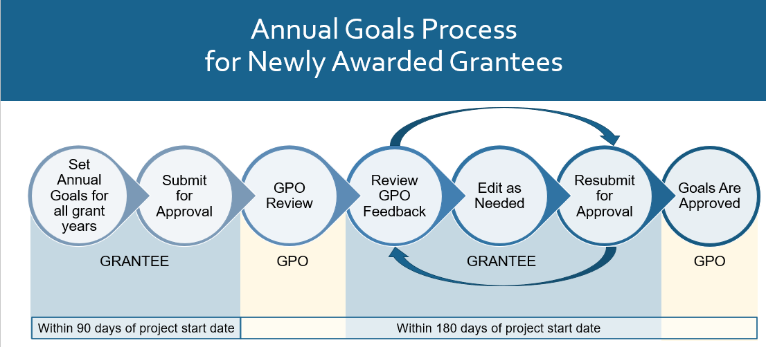
Figure 1.

The data entry steps in SPARS for the first two processes in Figure 1 above, Set Annual Goals and Submit for Approval, are detailed in the following sections of this guide:
- Step 1: Access CMHS Annual Goals in SPARS
- Step 2: Select program(s) or grant(s)
- Step 3: Enter Annual Goals for a CMHS Grant (New Grants)
Once the annual goals have been submitted, the GPO will review the annual goals in SPARS. After the GPO review, grantees will review GPO feedback, edit and resubmit annual goals (if needed) using the instructions in the following section of this guide:
- Step 4: Review Annual Goals and GPO Feedback
Once all the annual goals are approved by the GPO, the process is complete for the initial entry of the annual goals in SPARS.
For subsequent grant years, you can revise annual goals in consultation with your GPO during the first quarter of each fiscal year (that is, October-December) regardless of the original project start date. SPARS allows entry and editing of annual goals during the first quarter of each fiscal year. See Figure 2 below for an overview of the optional, annual goal setting process.

Figure 2
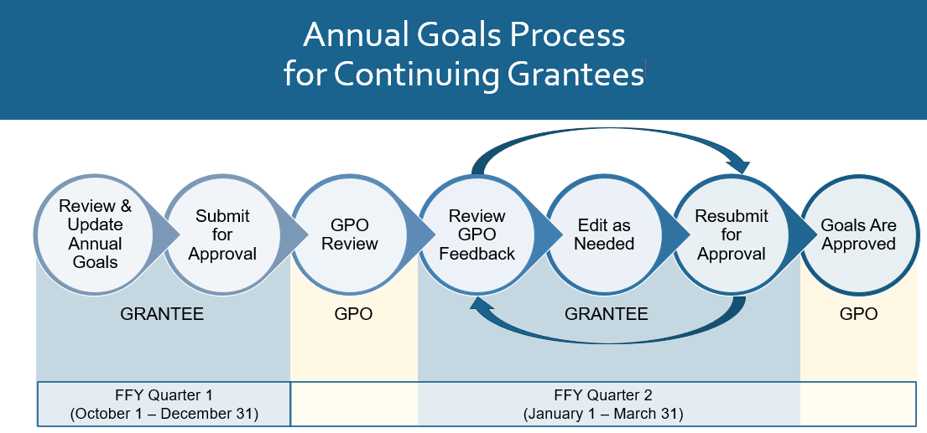
If you update your annual goals in the first quarter of a fiscal year, grantees will follow the data entry steps outlined in the following section of this document:
TIP | The goal for direct services – Clients Served – is set in the same place as the IPP annual goals. For more assistance on how to set annual goals for IPP indicators, see the IPP Overview Guide [coming soon].
- Step 5: Update Annual Goals Information (Continuing Grants)

SPARS Data Entry Step-by-Step for Clients Served Annual Goals

STEP 1: Accessing CMHS Annual Goals in SPARS
To enter your annual goals, first log into SPARS. The web address for SPARS is https://spars.samhsa.gov/. Creating a bookmark enables easy access to the website.
Then, go to the CMHS section, and navigate to the “Annual Goals Data Entry” screen. There are two ways to navigate to the “Annual Goals Data Entry” screen.
The first way is to click SPARS-CMHS under the Quick Links section of the “SPARS” homepage to get started (see Figure 3).
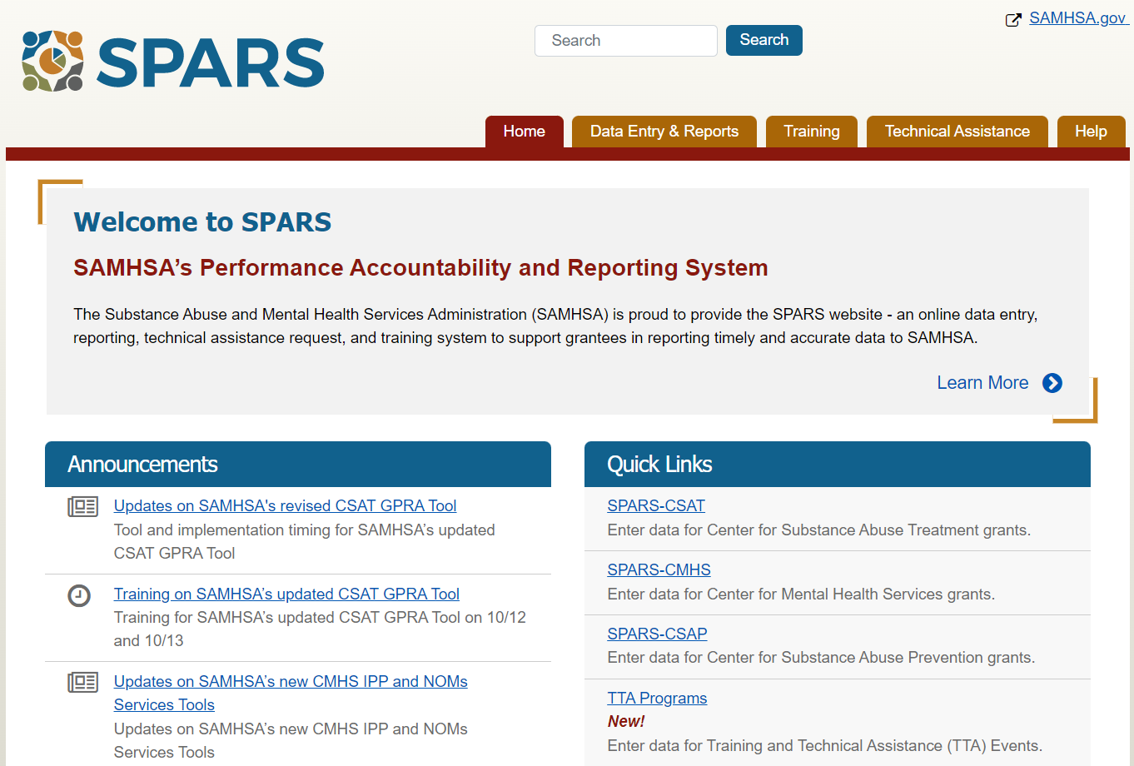
Figure 3

Alternatively, from the “SPARS” homepage, select the Data Entry & Reports tab, hover over for CMHS Users, and click CMHS Data Entry (see Figure 4).
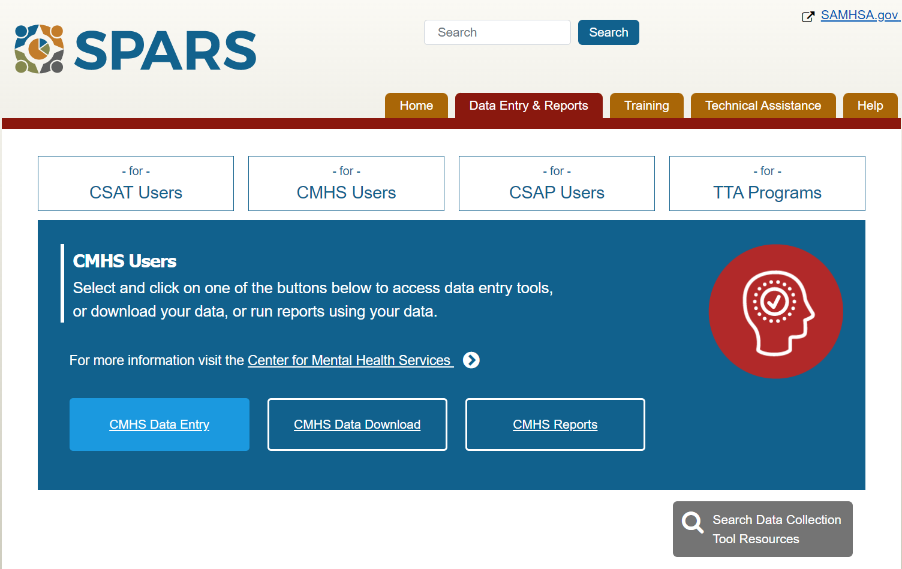
Figure 4

At this point, you will be prompted to log into SPARS if you have not already done so.

Next, click on Data Entry, and then click Annual Goals (see Figure 5).
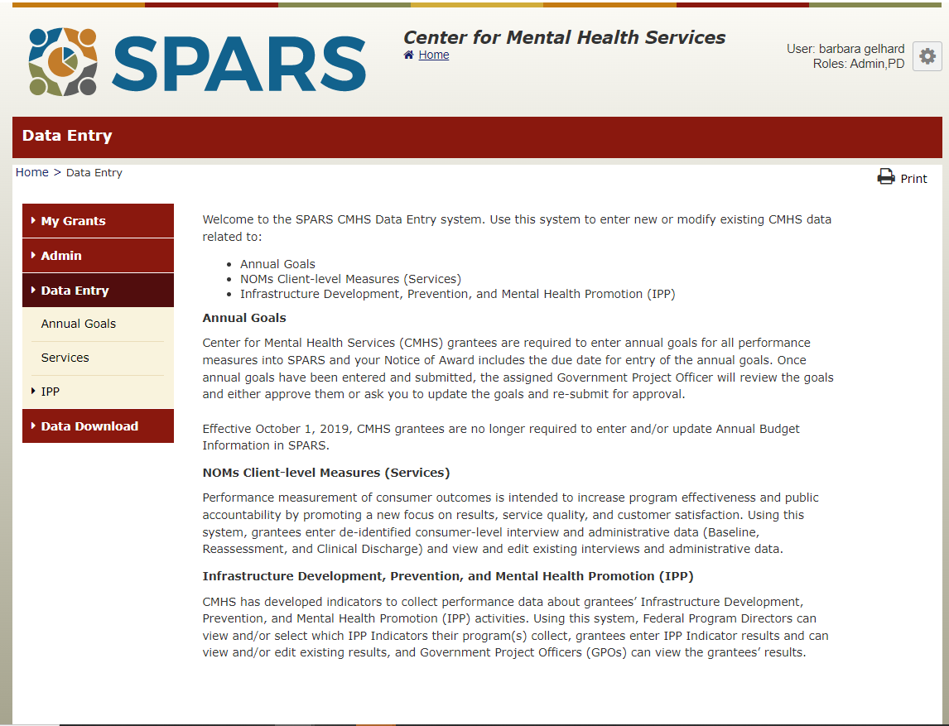
Figure 5

How do I get a SPARS account? | Notify your organization’s Project Director, Alternate Project Director, or Authorized CMHS Representative that you need a SPARS account. Project leadership should use the Add/Remove SPARS Users Form to request an account. Once the form is completed, your Project Director or Authorized CMHS Representative will need to submit the completed form to the SPARS Help Desk (SPARSHelpDesk@mathematica-mpr.com).  Once SPARS receives the required information, Help Desk staff will set up an account, and then you will receive login credentials via email. Grantees who have multiple roles or who work on grants with more than one organization may require multiple accounts that use different login information.

How do I get help with problems accessing SPARS? | For technical support or problems logging into SPARS, please contact the SPARS Help Desk.  Telephone: 1-800-685-7623  Email: SPARSHelpDesk@mathematica-mpr.com  Hours: Monday-Friday, 9:00 AM-8:00 PM (ET)

STEP 2: Select program(s) or grant(s)
If your SPARS account is only associated with one grant, the system will bring you directly to the first data entry screen.
If you have access to multiple grants, you will first see the “Find Grant” screen. If you leave the “Find Grant” form blank and select the Find button, the system will display a list of all the grants to which you have access (see Figure 6).
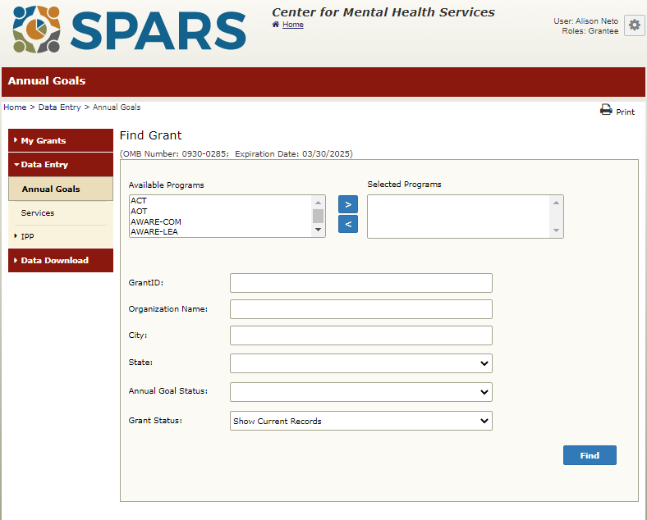
Figure 6

To search by program, click on the program name in the left box and then click on the > button to move the desired program from the Available Programs side to the Selected Programs side. If you select the incorrect program, click the < button to move it back. After your program(s) has been selected, click the Find button at the bottom of the screen, and the appropriate grant(s) appear in the grant list at the bottom of the page.
You can also search for a grant by Grant ID, Organization Name, City, and/or State by entering information you know into the appropriate boxes and then clicking on the Find button. SPARS will list all records that match the criteria you entered.
Next, click Select on the grant for which you want to enter Annual Goals (see Figure 7).
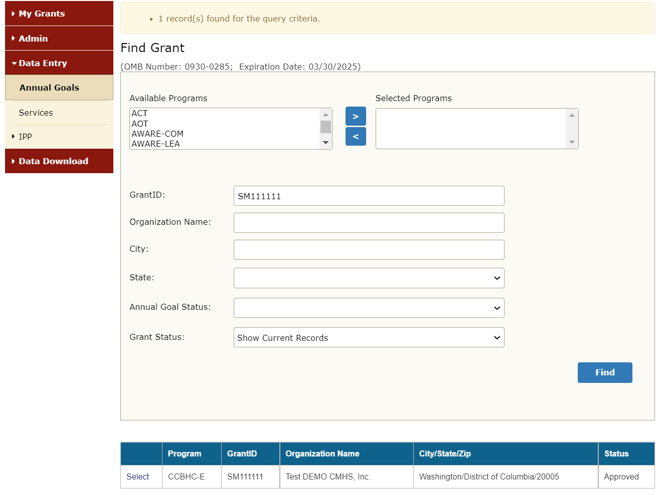
Figure 7

STEP 3: Entering Annual Goals for a CMHS Grant (New Grants)
After selecting the grant for which you want to enter Annual Goals, new grantees will be taken directly to the data entry page.
SPARS will only display the Services goals if you are assigned NOMs client-level data collection and reporting. After completing a section, click on the Save button at the top of each screen. It is not necessary to complete all Annual Goals sections in one sitting; you can save your work and return to complete them later.
At the beginning of each Goals page, there are on-screen instructions that provide details for how to complete the section (see Figure 8).
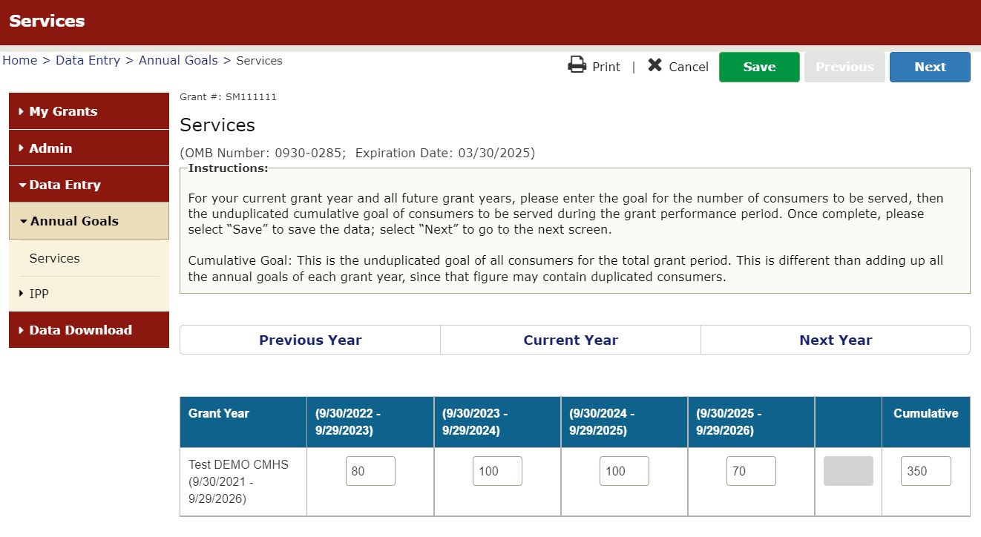
Figure 8

For clients served, you will need to enter a goal for each fiscal year your grant is active. Enter a zero (0) if you think your grant will not serve any new clients in a given fiscal year (e.g., if awarded May 31 and plan to enroll clients for the first time starting in October, the next fiscal year). However, please consult with your GPO before entering ‘0’ for any Annual Goal. You cannot leave any field blank.
Services grants require a cumulative goal as well, the cumulative number is the sum of the years.
Note: This guidance is a change from previous years. Annual Goals should now equal the number of new baselines / episodes of care / new enrollees each fiscal year of the grant.

REMEMBER TO SAVE!
If you have entered your Annual Goals for clients served and you would like to save and submit at a later time, click the Save button at the top of the screen. If you do not click the Save button, your goals will not be saved in the system. Otherwise, click the Next button at the top of the screen to move to the next applicable screen (Figure 9).
Figure 9

Grantees assigned IPP Indicators will see data entry page(s) for their annual IPP Indicator goals next. Both Services and IPP Indicator goals must be entered before any Annual Goals can be submitted, and grantees must enter Services goals before SPARS will allow grantees to move forward onto the IPP Indicator goals data entry page(s). Once all Annual Goals are entered, the system will display the “Grantee Approval/Submission” screen. This screen provides a summary of all the Annual Goals data entered for the grant.
Review the data for accuracy. To make any edits, click on the Previous button at the top of the screen to go back to the appropriate screen (Figure 10).
If you are not ready to submit your data for approval, click on the Save And Quit button to save your data and take yourself back to the “Find Grant” screen.
Please Note: If you click the Cancel option next to Print, you will leave the page, and your changes will not be saved.
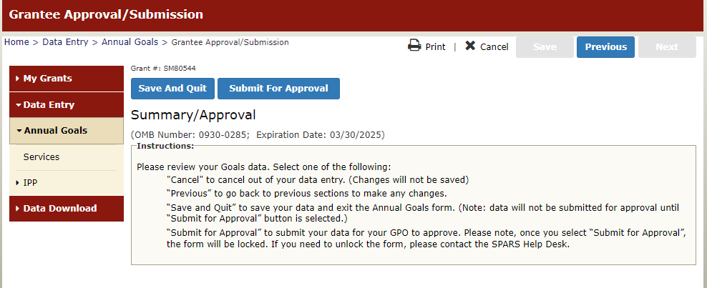
Figure 10

When you are ready to submit your Annual Goals to your GPO for approval, click the Submit For Approval button (Figure 11)—your GPO will not be able to review your goals unless you have clicked this button. The Submit For Approval button will only be enabled when all your required goals, including both Services and assigned IPP Indicators goals, are entered into SPARS. Once you click this button, the data entry screen will lock, and you will not be able to edit your Annual Goals data until the first quarter (October–December) of the following fiscal year unless the GPO disagrees and requests edits to the goals you have submitted.
Figure 11

After submitting for approval, grantees can check the status of their program goals. Immediately after submitting, the status should be “Ready For Approval” (Figure 12).

What if I find a mistake AFTER submitted for approval? | If you have submitted your Annual Goals for GPO review but your GPO has not reviewed it, you can let them know you made a mistake and ask them to disagree with that goal so you can edit it. If your GPO has approved your Annual Goals and they need to be unlocked so you can make edits please use the CMHS Annual Goals and IPP Request Form [coming soon], and contact the SPARS Help Desk.  Telephone: 1-800-685-7623  Email: SPARSHelpDesk@mathematica-mpr.com  Hours: Monday–Friday, 9:00 AM–8:00 PM (ET)
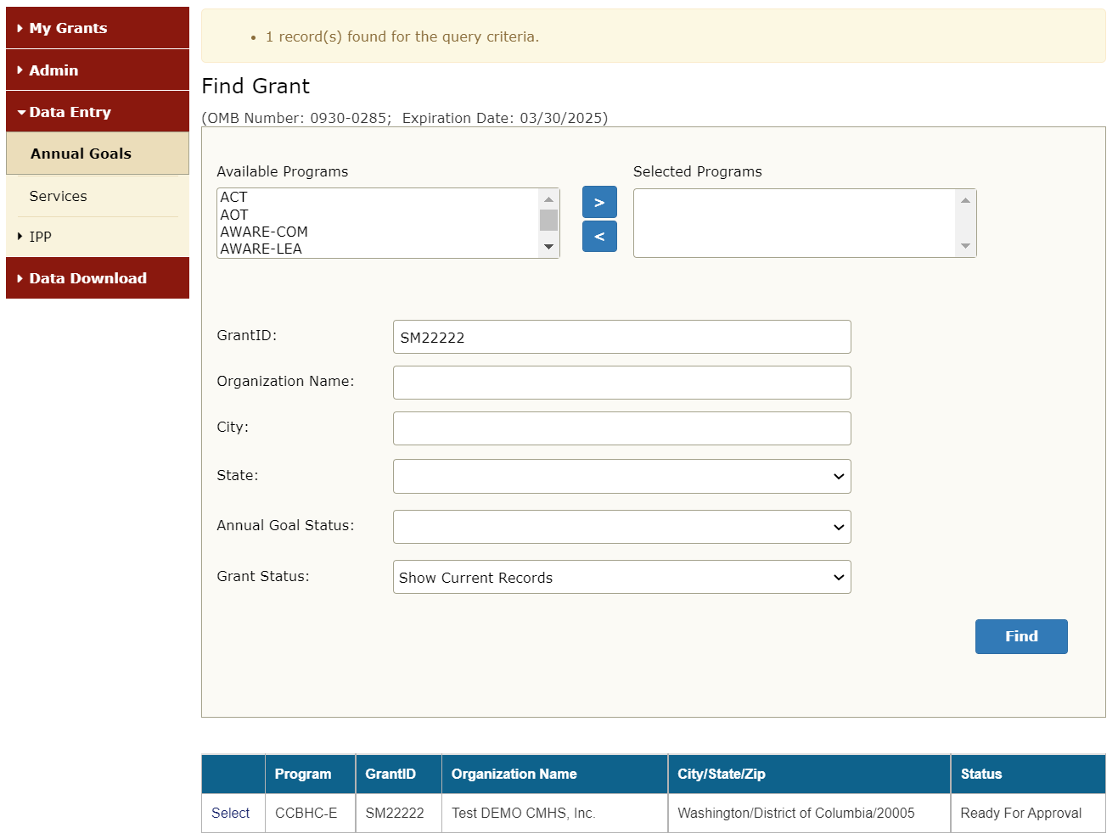
Figure 12

STEP 4: Review Annual Goals and GPO Feedback
Your GPO will review your Annual Goals after you have clicked on the Submit For Approval button. An email will be sent to you when your GPO has either approved your Annual Goals or has indicated they do not approve one or more of your Annual Goals.
If you receive notification that your GPO did not approve your Annual Goals, you must go back into SPARS and view the Annual Goals and any GPO comments. You can view the Services goal approval status by following Step 2 above to find your grant(s). The Annual Goals approval status will appear in the far-right column of the chart at the bottom of the screen (e.g., “Approved,” “Update and Resubmit for Approval”; Figure 13).
Select the grant for which goals need to be edited by clicking the Select link shown at the far-left column of the table at the bottom of the screen (Figure 13).
Figure 13
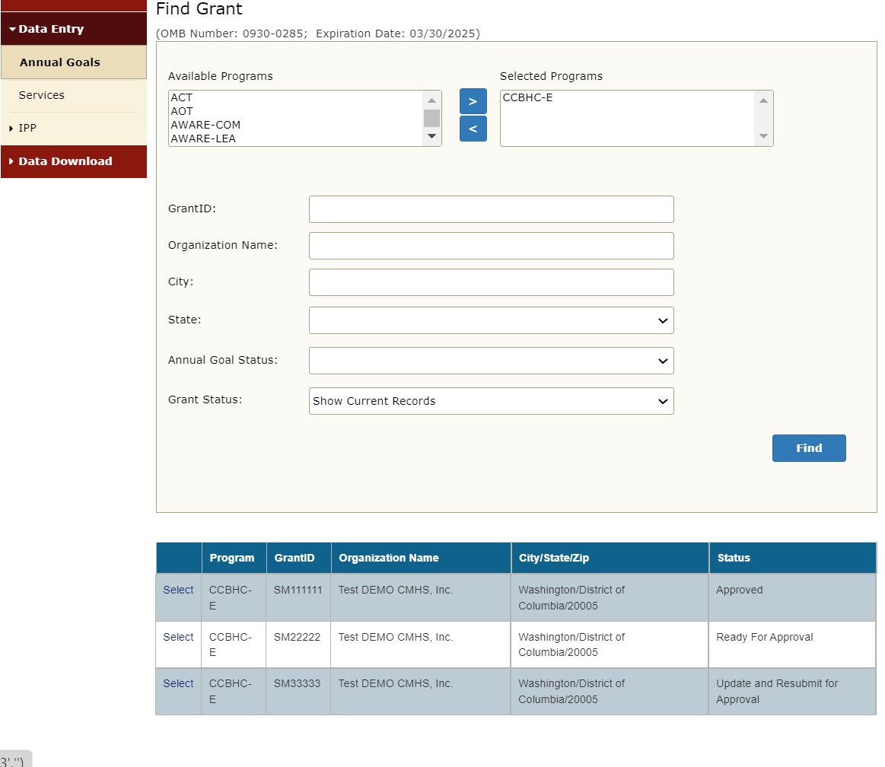

In the lower part of the screen, choose No, I want to review my data to edit goals that have been disapproved by the GPO, and then click Next (Figure 14).
Figure 14
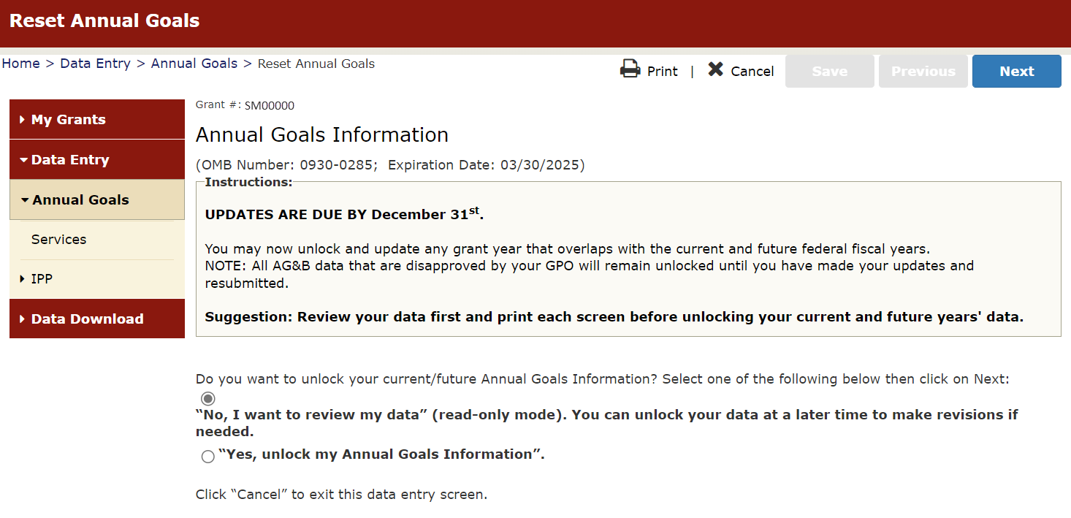
Figure 14

You will first see the status of the grant’s annual Services goals; if you click Next to move on you will see the annual IPP goals. You will see the most recently entered goals highlighted in yellow boxes and editable (Figure 15), and the GPO’s comments in a box toward the bottom of the screen in the free text box. The GPO’s comments may include an explanation of why the goal was rejected and suggestions for corrections.
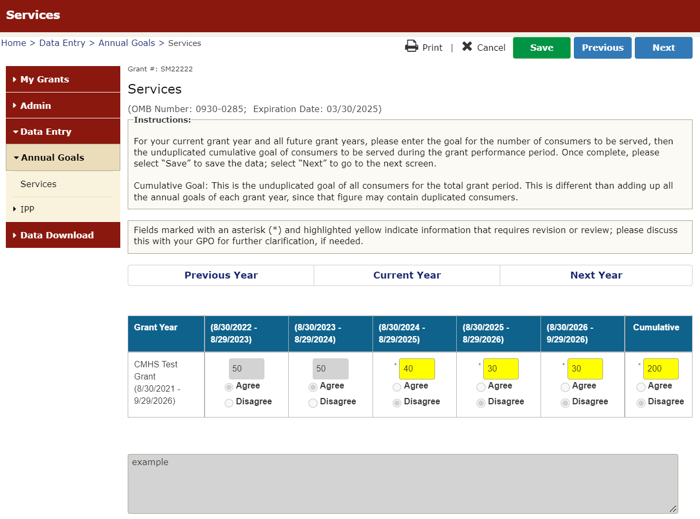
Figure 15

Once you review, you should edit the information and then select the Submit For Approval button again to resubmit your Annual Goals data for the GPO.

After the GPO approves the annual goals for a grant, that grant will show an “Approved” status (Figure 16).

TIP | Keep track of your annual goals and changes during the review process outside of SPARS (for example in a Word or Excel document) to go through review and approval processes within your organization and make data entry into SPARS easier. In the same place, keep any communication from GPOs or questions on why goals were not approved or how you were asked to revise goals for approval.
Figure 16

STEP 5: Updating Annual Goals Information (Continuing Grants)
During the first quarter of each fiscal year (i.e., October–December), SPARS allows you to unlock your annual goals for review and revision as needed. If the information you entered into SPARS under Annual Goals is in a status of “Approved” during quarter one, you will be able to unlock the information for the current and future grant years to make revisions, as shown in the screenshot below (Figure 17). GPOs can review and recommend edits at any time during the first quarter of each FFY and for one quarter after the update period (January 1–March 30).
If you have previously submitted Annual Goals data, you will see the screen below that allows you to unlock your previous entries for revision. To revise your previous entries, select Yes, unlock my Annual Goals Information, and click the blue Next button in the upper right corner.
If you are a new grantee, or if you did not fully complete the Annual Goals process last year, you will not see the screen below. Instead, you will be taken directly to the data entry screens.
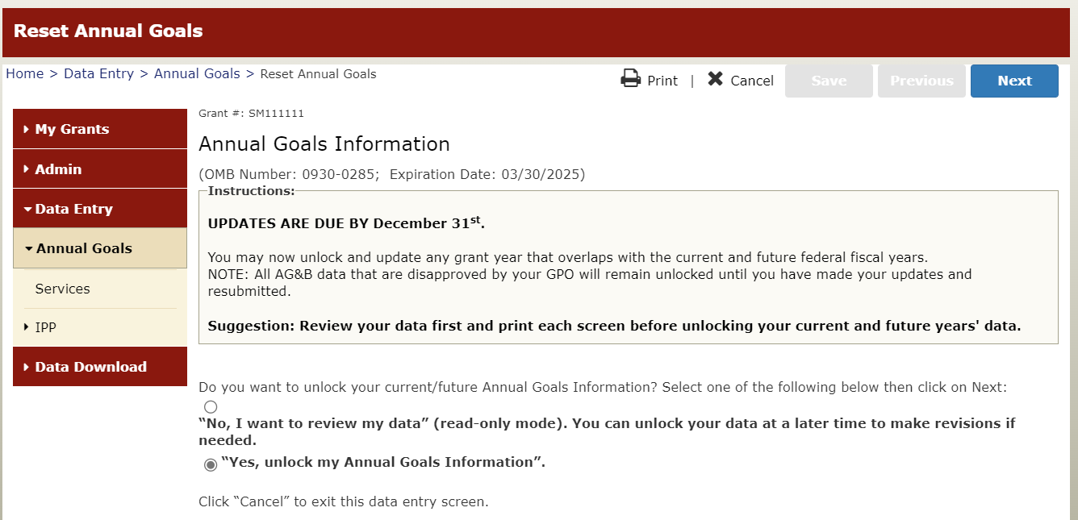
Figure 17

Please note that if you unlock your information, your GPO will have to review and approve it, even if you do not make revisions. Therefore, it might be a good idea to review your information first and then unlock it only if you need to make changes.
- If you click No, I want to review my data, you will be taken to the first data entry screen in a read-only mode if all your goals have been approved. If there are any goals that the GPO disagreed with, the goal will be highlighted in yellow and editable. Once you have reviewed your data, you can come back to this screen and unlock the information later if needed.
- If you click Yes, unlock my Annual Goals Information, you will be taken to the “Warning” screen (Figure 18) indicating that the data will be unlocked for editing. This button should only be utilized during quarter one to unlock approved goals.

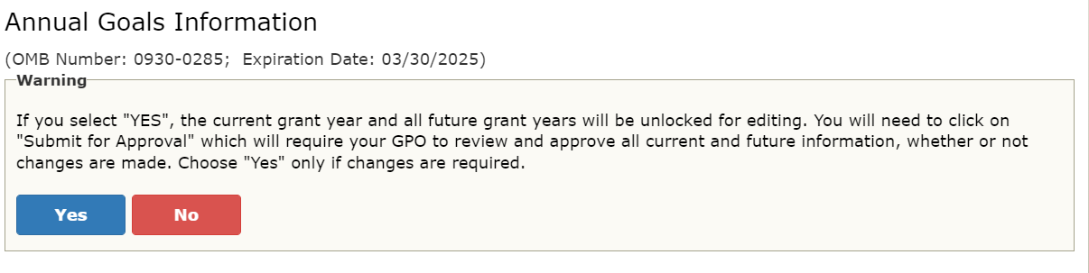
Figure 18

If you click No on this screen, you will see the data entry screens in read-only mode.
If you click Yes, you will be taken to the data entry screens with the current and future year fields editable.
Please note: Any information that was set to “Disagree” by your GPO from previous years will be highlighted in yellow and will be editable, as shown in the image below (indicated with the orange highlight box; Figure 19). Before making changes to Annual Goals, continuing grantees should discuss any planned changes with their GPO.
Figure 19
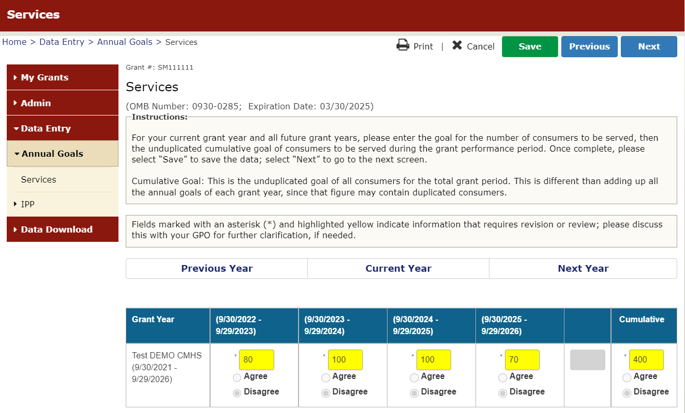

If you are not ready to submit your data for approval, click on the Save And Quit button (Figure 20) to save your data and take yourself back to the “Find Grant” screen.
Please Note: If you click the Cancel option next to Print, you will leave the page and your changes will not be saved.
Figure 20

After making changes, select the Submit For Approval button again (Figure 21) to resubmit your annual goals data to the GPO for review.
Figure 21
Go back to Step 4 above for GPO review and feedback.

Reporting NOMs in SPARS [Coming Soon!]
Version November 2022

Accessing NOMs data from SPARS [Coming Soon!]
Version November 2022

SAMHSA’s Concept of Trauma and Guidance for a Trauma-Informed Approach (SAMHSA's Concept of Trauma and Guidance for a Trauma-Informed Approach)
Trauma Screening | The National Child Traumatic Stress Network (https://www.nctsn.org/treatments-and-practices/screening-and-assessments/trauma-screening)
Children’s Trauma Assessment Center (https://www.nctsn.org/sites/default/files/resources/trauma_screening_checklist_identifying_children_at_risk_0-5.pdf)
American Psychiatric Association. (2022). Diagnostic and statistical manual of mental disorders (5th ed., text rev.). https://doi.org/10.1176/appi.books.9780890425787 Coding updates to DSM-5 https://www.psychiatry.org/psychiatrists/practice/dsm/updates-to-dsm/coding-updates/2021-coding-updates
Centers for Medicare and Medicaid Services, “ICD 10” https://www.cms.gov/Medicare/Coding/ICD10.
Centers for Medicare and Medicaid Services, “Using Z Codes: The Social Determinants of Health (SDOH) Data Journey to Better Health” https://www.cms.gov/files/document/zcodes-infographic.pdf.
https://lgbtqequity.org
Learning About Sexual Orientation, Gender Identity, and Expression | SAMHSA (https://www.samhsa.gov/resource/dbhis/learning-about-sexual-orientation-gender-identity-expression)
https://lgbtqequity.org
Culturally and Linguistically Appropriate Services – Think Cultural Health (https://thinkculturalhealth.hhs.gov/clas)
Service Members, Veterans, and their Families Technical Assistance (SMVF TA) Center | SAMHSA (https://www.samhsa.gov/smvf-ta-center)
Service Members, Veterans, and their Families Technical Assistance (SMVF TA) Center | SAMHSA (https://www.samhsa.gov/smvf-ta-center)
Implementing Standards for Person-Centered Planning and Self-Direction in Home and Community-Based Services Programs | Guidance Portal (hhs.gov)

